Virginia Corn Board 2025 Report and 2026 Proposal

Title: Rapid Determination of Cover Crop Biomass for Nutrient Management and
Evaluation of Biological/Biostimulants in Virginia Corn Production.

Principal Investigator: Dr. William “Hunter” Frame
Field Crops Agronomist/Associate Professor
Virginia Tech
Tidewater AREC
PH: 757-807-6539
Email: whframe@vt.edu

Co-PI(s): Dr. Ryan Stewart
Soil Water Management/Soil Physics
PH:540-231-0253
Email: rds@vt.edu

Project Initiation: April 2026

Project Duration: April 2024 – October 2027 (1-year for the current proposal)

Objectives: 1. Develop nitrogen response recommendations based on cover crop biomass and nutrient content within different cover crop species/group to better estimate nitrogen application rates across fields.

2. Develop a rapid method to determine cover crop biomass at the field level using NDVI/LIDAR for precision nitrogen management in corn.

3. Evaluate six to twelve commercial biological/biostimulant formulations on nutrient uptake and efficiency in corn in Virginia.

Locations: Experiment 1: On-farm locations across Virginia (Split between
Coastal Plain and Piedmont)

Experiment 2: Tidewater Agricultural Research and Extension
Center (Suffolk, Va) and VA Ag Expo Location (Orange, VA in 2025)

Summary for On-Farm Cover Crop and Biostimulant studies in Virginia Corn (2025)

Executive Summary

In 2025, both experiments were highly successful overall with great data produced and there were some outstanding corn yields. Two locations were identified for the on-farm evaluation of cover crop biomass and its contribution to soil nitrogen levels and nitrogen application rates in corn. The sites were in Essex and Surry Counties for the 2025 studies. The Essex County location was planted to winter wheat cover crop and the Surry County location was planted to hairy vetch cover crop. Responses to nitrogen were observed at both locations and with grain yield ranging from 52 – 218 bushels per acre for the studies.
For the biostimulant/biological product evaluation trials grain yields ranged from 170 – 231 bushels per acre at the Ag Expo site and 107 – 228 bushels per acre at the TAREC location. No differences were observed in grain yield among biological/biostimulants at either location, however differences were observed in nitrogen uptake and nitrogen use efficiencies among products. Nitrogen use efficiencies were 48.3 and 52.9% for TAREC and Ag Expo, respectively. More data are needed over multiple sites and years to better understand how these products perform.

2025 Experiment 1 Results
Two trial locations were selected for the on-farm cover crop N prediction algorithm in 2025. One location was in Essex County, Virginia (Figure 1) and the second location was in Surry County Virginia (Figure 2). At each location NDVI was measured using a DJI Mavic 3 Multispectral UAV and areas of “high” and “low” biomass were selected within each field. The
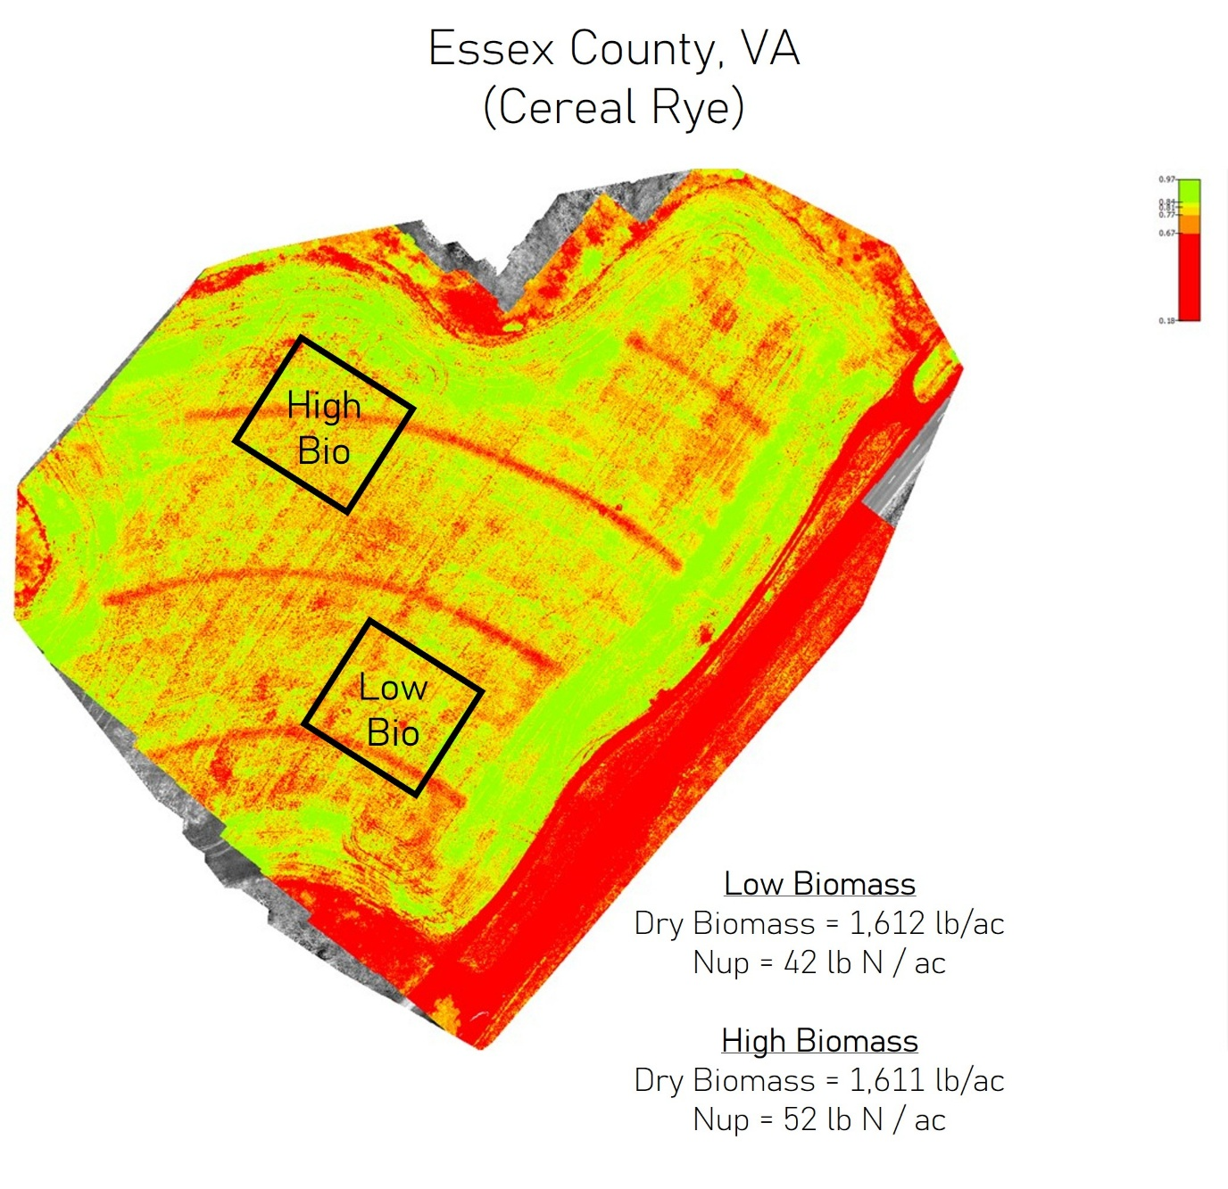
Figure 1: Normalized difference vegetative index map and approximate N prediction study location with the high and low biomass areas in Essex County, VA during 2025.
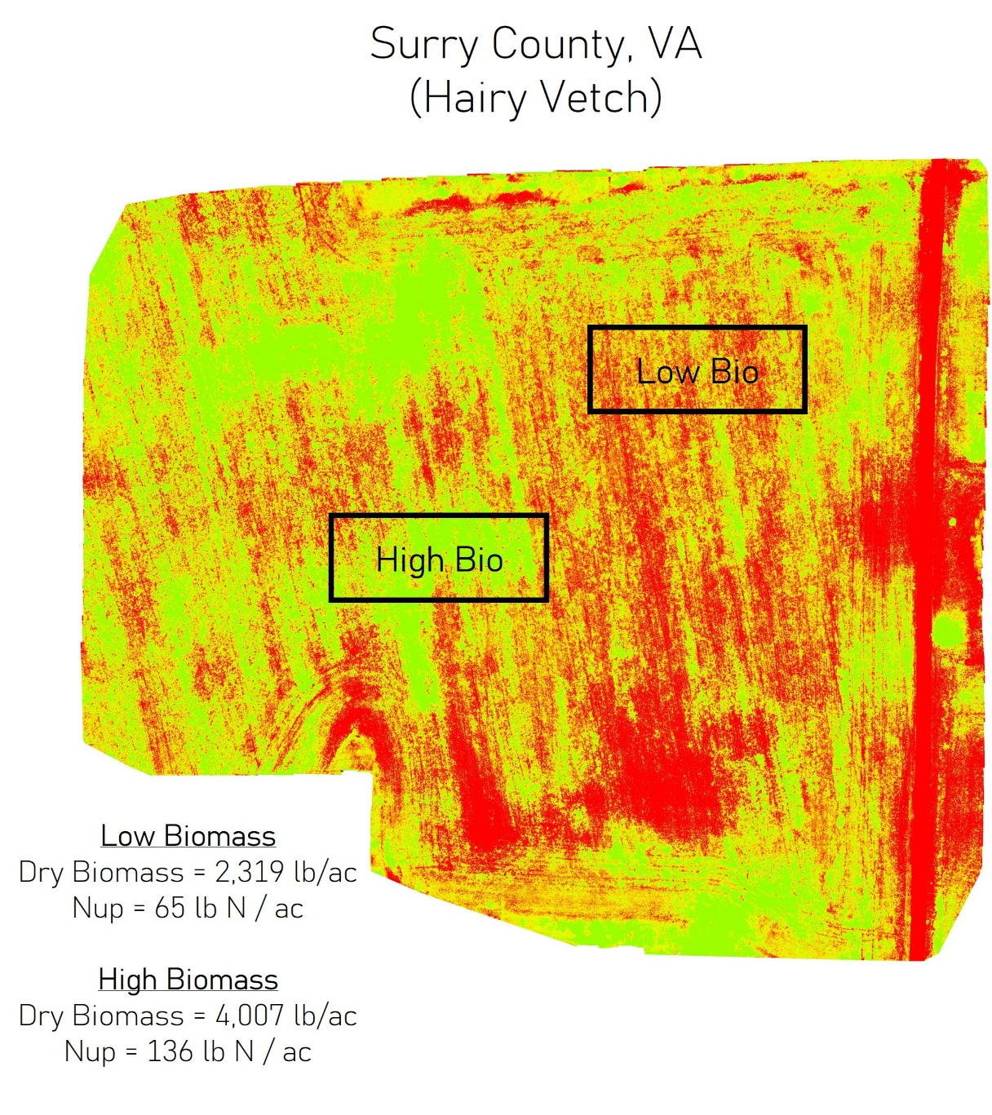
Figure 2: Normalized difference vegetative index map and approximate N prediction study location with the high and low biomass areas in Surry County, VA during 2025

cover crops were winter wheat in Essex and hairy vetch in Surry. In Essex, winter wheat biomass was equal across the field with 1,611 – 1,612 lb per acre and nitrogen (N) uptake ranging from 42 – 52 lb N per acre in the cover crop (Figure 1). At the Surry location, there were greater differences in cover crop biomass with the high are having 4,000 lb dry biomass per acre and 136 lb N per acre in that biomass (Figure 2). For the low biomass area the hairy vetch produced 2,319 lb dry biomass and 65 lb N per acre in that biomass (Figure 2).
Since cover crop biomass was the same between zones in Essex and the farmer terminated the cover crop prior to jointing both zones were treated the same using the predictive N algorithms. The predicted N rates were 166 and 168 lb N per acre and performed similarly to the 150 and 200 lb N per acre rates in the response curve (Figure 3). Grain yields were maximized with 150 lb N per acre for both cover crop biomass zones in Essex (Figure 3). At this location, the predictive N models performed well in predicting the optimal N application rate. However, this location was managed for low biomass accumulation and little to no N was immobilized by the small grain cover crop.
At the second location in Surry, the cover crop was hairy vetch as there were growth differences at this site. The high growth area maximized grain yield at 198 bushels per acre with 150 lb N and the predictive N models varied with 164 and 144 lb N per acre recommended, for PSA and PSU respectively (Figure 4). The 164 lb N per acre predicted by PSA was adequate to maximize yields, whereas the PSU model underpredicted side-dress N with 144 lb N per acre and a grain yield of 167 bushels per acre (Figure 4). The 0 lb N per acre control yielded 140 bushels per acre and demonstrates that a significant portion of the cover crop N is available during the growing season. For the low cover crop biomass area, grain yields were significantly lower and demonstrates where the predictive N models start to fail in low CEC, coarse textured soil that have reduced yield potential. These soils are commonly found in the coastal plain regions and models need to be able to produce recommendations based on yield expectations for the soil type. Though grain yields increased with increasing N application rates yields were maximized at 122 bushels per acre (Figure 4). This was below the 0 lb N per acre application rate just a few hundred feet from the high cover crop biomass area.
The initial use of LIDAR to measure cover crop biomass was a success (Figure 5). A handheld LIDAR scanner was used to collected height and density images from the cover crop/crop rotation study in 2025 and the results from the scan are very promising for predicting cover crop biomass in the future and may be more accurate than traditional NDVI techniques. The correlation between cover crop biomass had an R² value of 0.77 for various single species and cover crop mixtures (Figure 5). More data are needed to further refine this correlation in the future and this will be repeated in 2026. One drawback to using LIDAR is the sheer size of the data files collected as each were dozens of gigabytes.
2025 Experiment 2 Results
Overall, the biological/biostimulant studies were high yielding and there were N application rate responses at both locations regarding nitrogen uptake (NUP), nitrogen use efficiency (NUE) and grain yield (Figures 6-8). Nitrogen uptake increased with increasing N application rates at both locations, however the Ag Exp (Orange) location had greater uptake at lower N application rates compared to TAREC (Suffolk) due to more residual soil N availability. There were significant differences in NUP at the Ag Expo site between biological treatments in 2025 (Figure 6). Consistently Utrisha N had higher NUP at both locations in 2025. Nitrogen use efficiency averaged 48% and 53% for the TAREC and Ag Expo sites respectively. No differences were observed in grain yield between biological products in 2025.

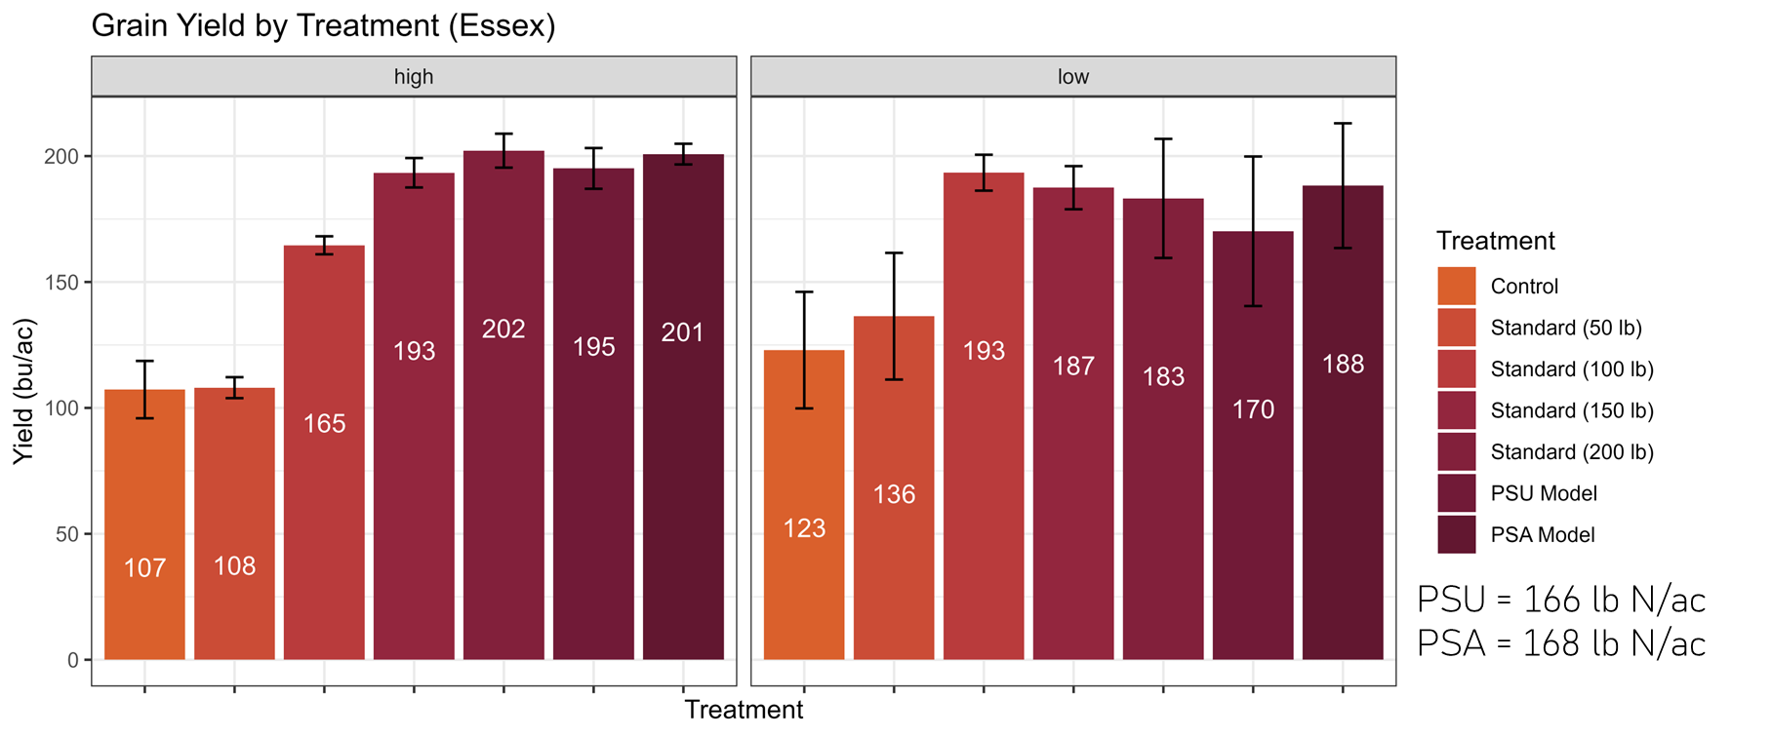
Figure 3: Grain yield at the Essex location for both the high (left) and low (right) cover crop biomass areas across various N application rates and the predicted N side-dress N application rates determined by the Penn. State University (PSU) and Precision Sustainable Agriculture (PSA) algorithms in 2025.

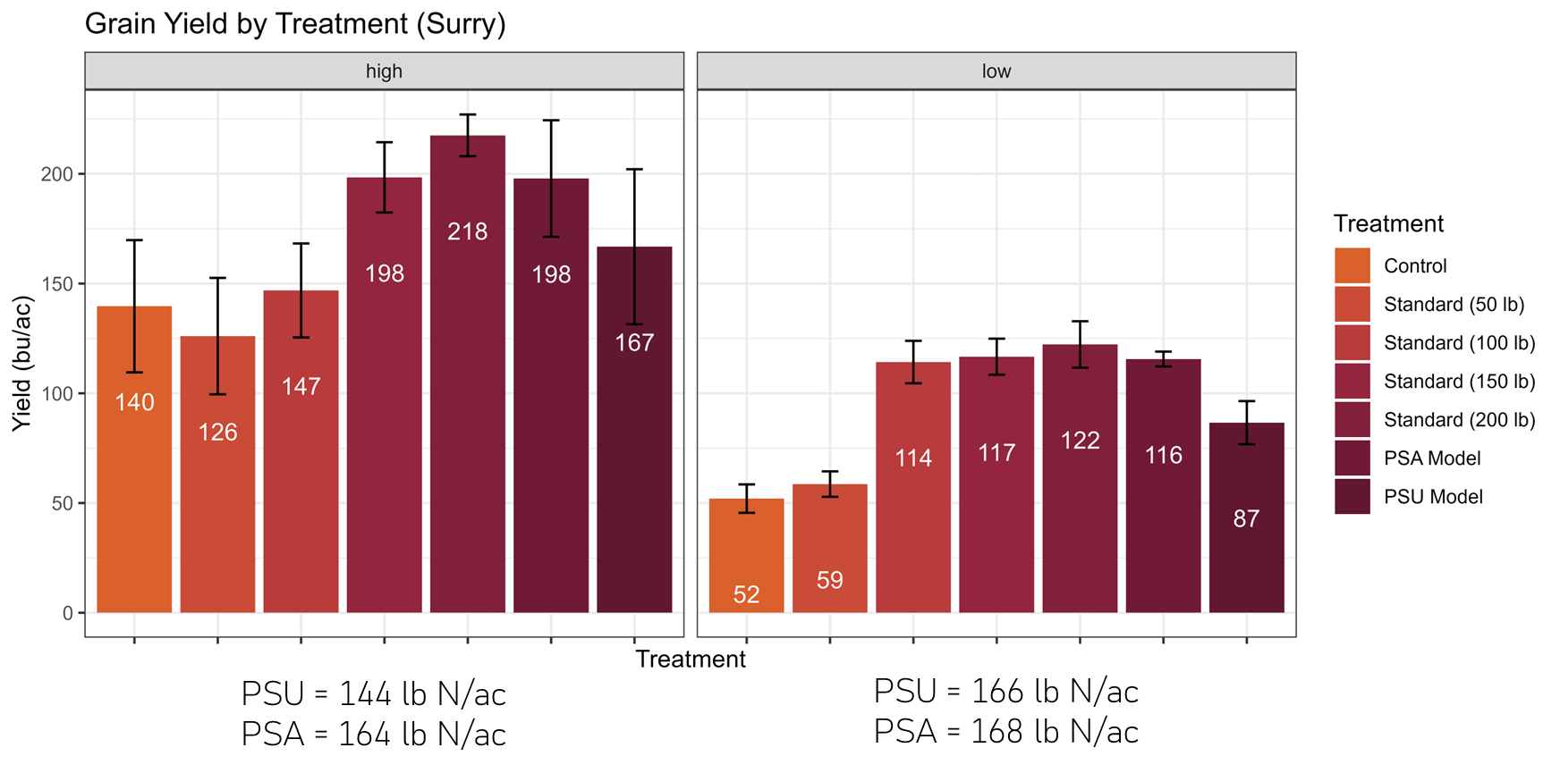
Figure 4: Grain yield at the Surry location for both the high (left) and low (right) cover crop biomass areas across various N application rates and the predicted N side-dress N application rates determined by the Penn. State University (PSU) and Precision Sustainable Agriculture (PSA) algorithms in 2025.

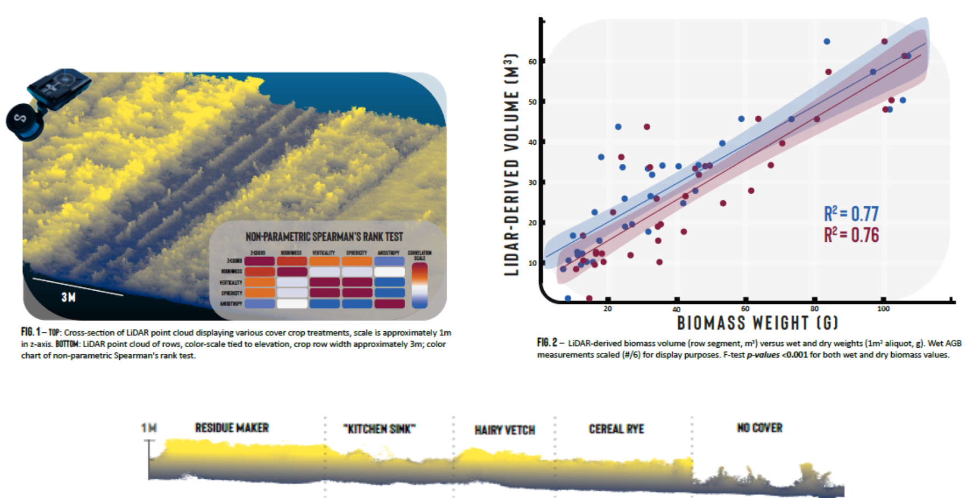
Figure 5: Results of initial LIDAR scanning of various cover crop mixtures and correlation to biomass in Virginia in 2025.

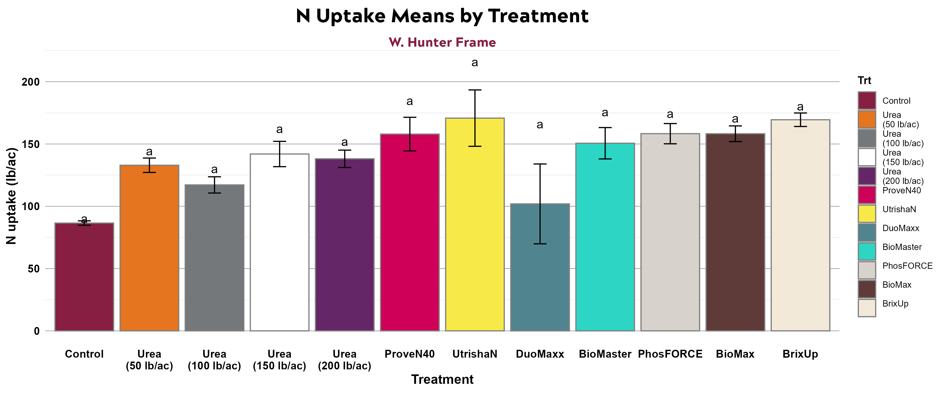
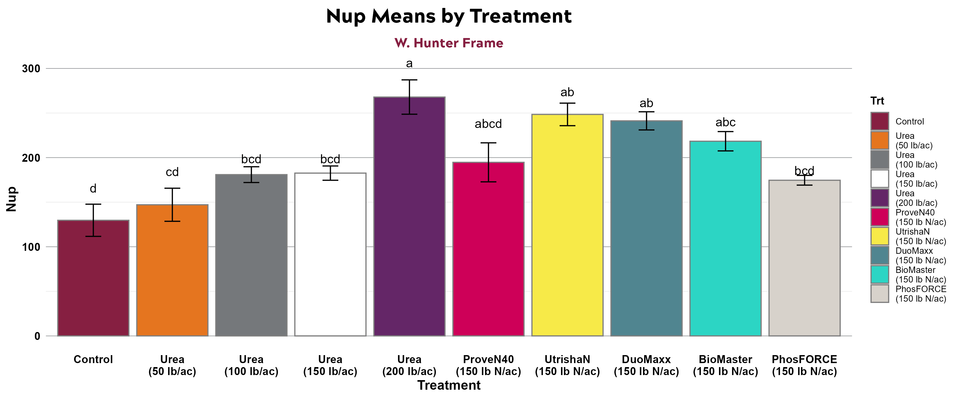
Figure 6: Total nitrogen uptake for all treatments at the TAREC (top) and Ag Expo (bottom) locations in 2025. Bars with the same letter are not significantly different at alpha = 0.1.

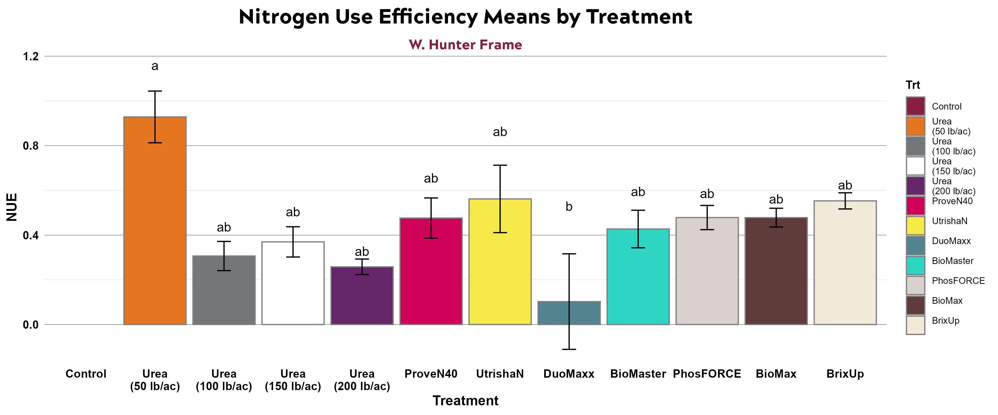
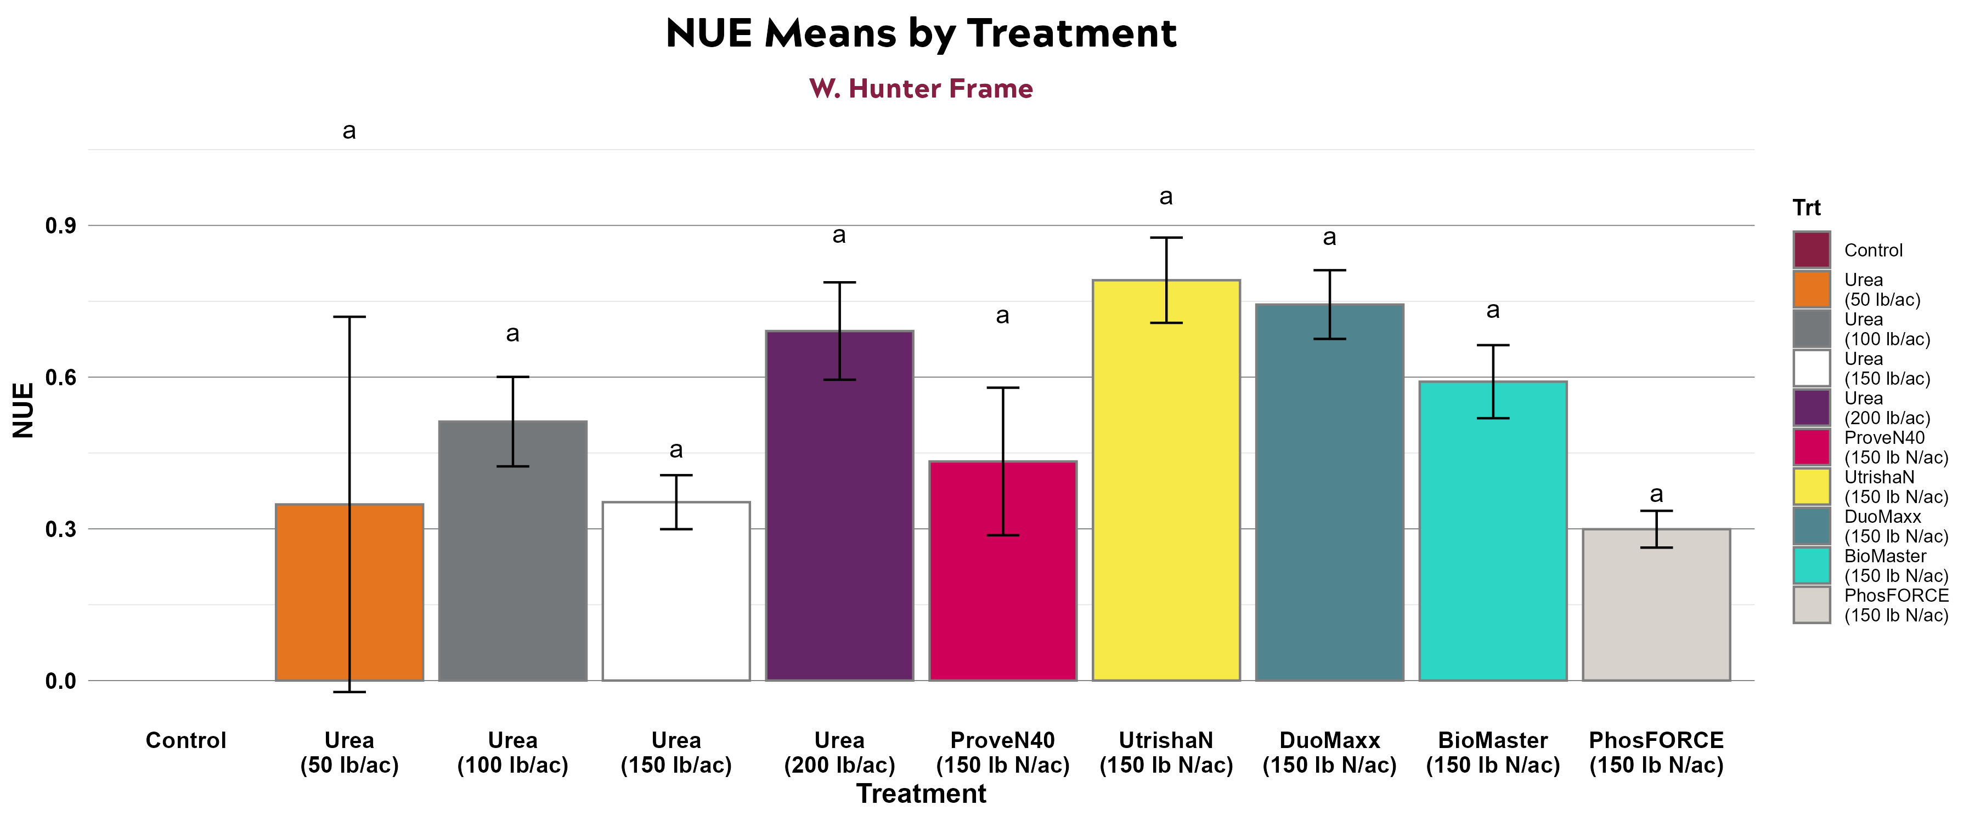
Figure 7: Nitrogen use efficienty (NUE) for all treatments at the TAREC (top) and Ag Expo (bottom) locations in 2025. Bars with the same letter are not significantly different at alpha = 0.1.

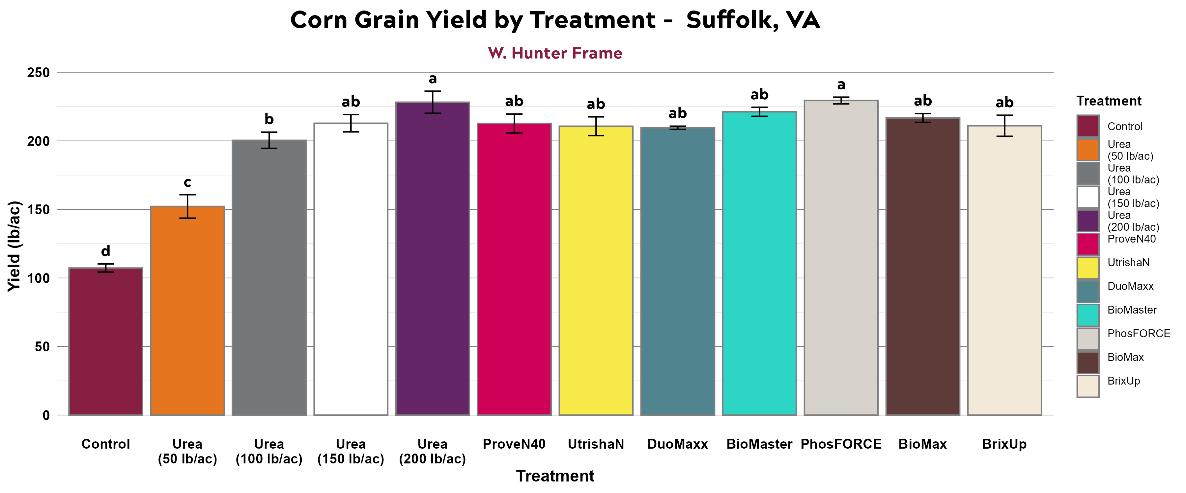
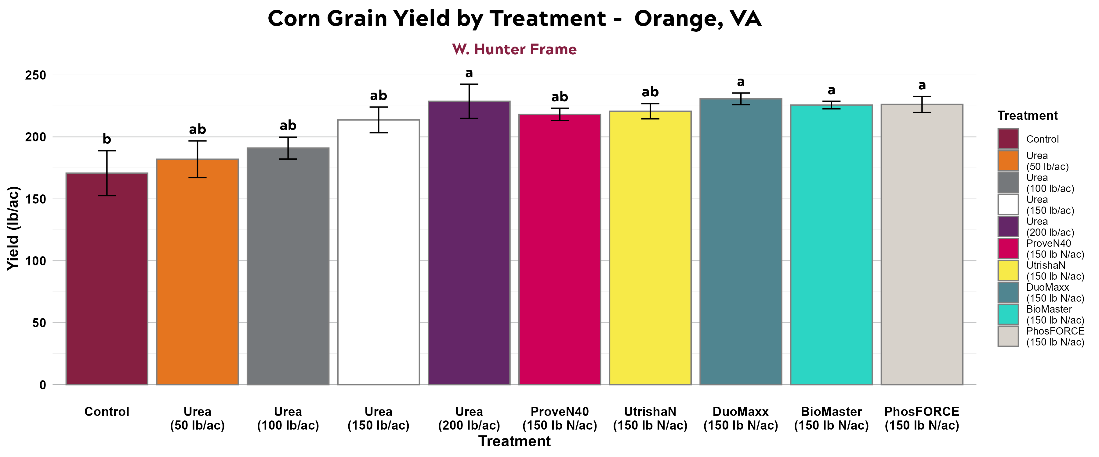
Figure 8: Grain yield for all treatments at the TAREC (top) and Ag Expo (bottom) locations in 2025. Bars with the same letter are not significantly different at alpha = 0.1.

2026 Research Proposal
Justification
Objectives 1 and 2
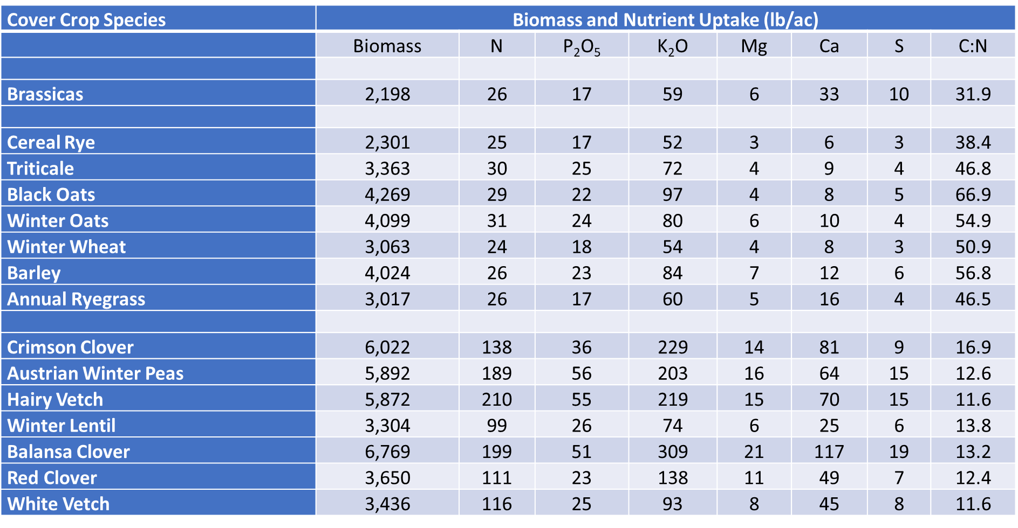
As cover crops become an increasing part of Virginia’s agroecosystems, especially for non-legumes such as corn and cotton, there is an increasing need to better understand how cover crops impact that cropping system. Nutrient cycling, especially nitrogen (N), can be modified greatly depending on the cover crop species and biomass accumulation present in each field. Species of cover crops affect N cycling differently as their carbon to nitrogen ratio (C:N) can varying greatly (Figure 4). At C:N ratios greater than 25:1, N can be immobilized/taken up by microorganisms who are competing with the crop for available N. Below 25:1, N is mineralized or released from the cover crop biomass at a level where competition with microorganisms is not a concern. Also, N uptake across cover crop species can vary greatly with small grains averaging 20 – 30 lb N per acre and leguminous species averaging from 99 – 210 lb N per acre (Figure 4).
Figure 9: Dry biomass, nutrient accumulation and C:N ratio for various cover crop species in a cover crop variety trial conducted at the Tidewater AREC in 2022.
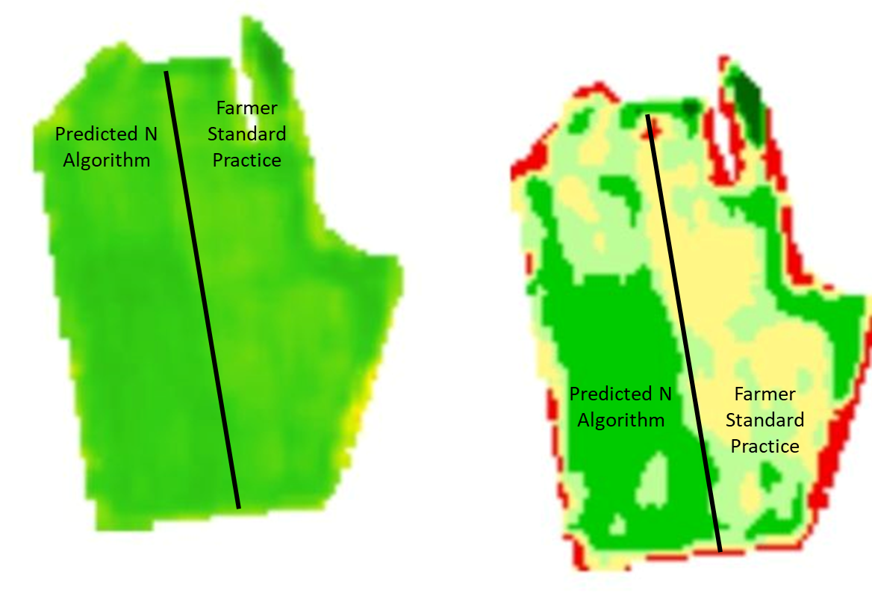
Figure 10: Normalized difference vegetative index (left) of cotton field in 2023 for a N prediction study with varying zones of poor (red – beige) and good growth (green) flown with a UAV and multispectral camera.

Agricultural fields are not uniform is production and crop growth (including cover crops) can be variable. Remotely measuring crop growth allows for a rapid determination of crop health or status during the growing season (Figure 6). Similarly to other aspects of measuring crop health this can be used to develop precision-based management strategies in real-time to optimized input efficiency and crop yield. Swoish et al. (2022) measured 86 sites in 26 agricultural fields in Virginia and found that the biomass prediction accuracy of satellite measured normalized difference vegetative index (NDVI) had an R² of 0.79. This gives confidence that cover crop biomass can be accurately predicted with current technologies, however little data exists that further evaluates the actual release of N in the biomass to the subsequent corn crop in manner to optimize grain yields. Other methodologies are also available that allow cover crop biomass to be measured more accurately such as normalized difference red edge (NDRE) index and light detection and ranging (LiDAR) (Miller et al, 2024 and Colaḉo et al., 2021). Prediction of cover crop biomass and resulting nutrient release to corn needs to be studied further and a model that accurately utilizes remote sensing data to predict nutrient release and uptake to optimize fertilizer N applications in corn is needed. A savings of just 10 lb N per acre across the 460,000 acres of corn would equate to 4.6 million lb of N with a value of $2.3 million savings to Virginia corn producers. Some data suggest that cover crops could provide greater than 100 lb N per acre which would be a value of $23 million in fertilizer N saving at $0.50 / lb N.
Objective 3
With ever increasing input costs in agricultural systems and commodity prices remaining flat for the past 10-15 years, there has been an increased emphasis on products that increase nutrient use efficiency or decrease reliance on fertilizers. This relatively new industry can be referred to as the Biologicals/Biostimulant industry and is estimated to have a total value of $13 billion by 2028. However, there are hundreds if not thousands of products on the market that are labeled as biofertilizer, biostimulants, and/or inoculants and this can be confusing for producers to wade through on which products work and will give them a return on investment. Figure 7 gives a representation of the biological companies (not products) that are currently advertising. There have been some regional studies across the United States Corn Belt that have had varying results. A study published by a joint research team found that across 61 sites, only two sites had

Figure 11: Companies that sell a agricultural biological product and the different classification of products in 2023. Taken from https://www.mixingbowlhub.com/landscape/2023-ag-biologicals-landscape

significant responses to biological products (Franzen et al., 2023). Gessinger et al (2024) also detailed multiple research projects for three prominent biological products in corn and report similar mixed responses to materials across all universities and studies. There is a need to better understand how some of the industry leading products aid in nutrient cycling and how they can be beneficial to corn producers in Virginia.

Background
Experiment 1
Cover crop research has been ongoing for thousands of years with the primary source of nutrients coming from animal manures and green manure crops (cover crops) up until 1930’s and the Green Revolution. Research has shown in Virginia that other crops such as cotton can be produced without any supplemental fertilizer N following green manure legume cover crops. This system drastically reduces the fertilizer input costs and increases the producer’s profitability. However, cotton does not require as great of quantities of N as corn, so the reality of supplying 100% of the corn N demand may be a stretch. With the development of cost-share programs in Virginia that have incentivized cover crop adoption there is a need for a more in-depth look at how cover crop impact current production practices in regard to nutrient management. Couple this with the technological ability to accurately and rapidly measure cover crop biomass using remote sensing technologies and you have the ability to predict how much N fertilizer a producer will need to apply to his corn crop (Swoish et al., 2022; Futerman et al., 2023; Hütt et al., 2023; and Prabhakara et al., 2015). Swoish et al. (2022) have proven this concept for cover crops in Virginia, but that study did not go into how that cover crop biomass influences corn N uptake and grain yield across Virginia.
Experiment 2
Agricultural biological products are a relatively new product class in the United States, though inoculants have been used for legume crops for centuries. The sheer volume of products and companies selling these products is overwhelming and little information is available on their performance. In Virginia, some data have been collected on a select few biologicals though these
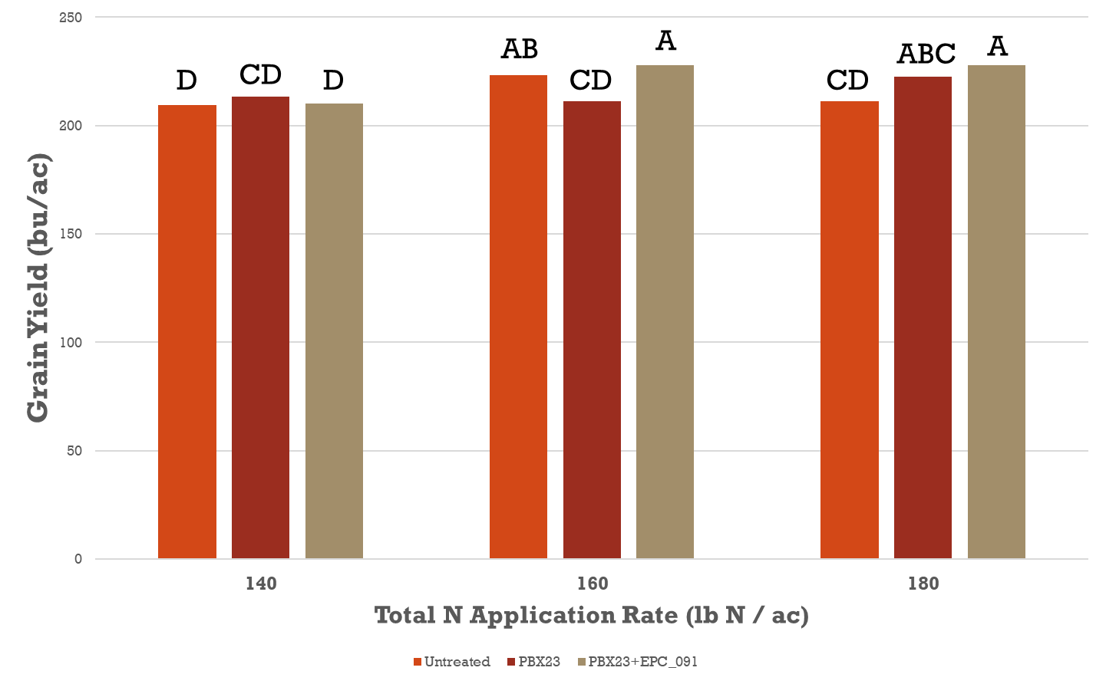
Figure 12: Corn grain yield impacted by Pivot Bio’s ProveN40 (PBX23) and an experimental additive in 2023 at Tidewater AREC.

products have not been tested over a large geographic area. Figure 8 is a study conducted in Virginia evaluating Pivot Bio’s ProveN40 product in corn and there were inconsistent yield responses during the trial. A study also on ProveN40 found about an 8 bu per acre yield increase applied in conjunction with subsurface drip irrigation in Virginia. Other than a handful of studies very little data is available outside of company data presented data. No significant responses to products such as Utrisha N and Envita have been observed when applied to cotton in Virginia as well. More data is needed to ascertain the real impact of the most prevalent biological/biostimulant products for Virginia’s corn producers.

Procedure
The proposal will include two experiments with the first experiment (Objectives 1 and 2) being conducted at three locations across Virginia (on-farm locations to be determined) and the second experiment (Objective 3) being conducted at two locations (Tidewater AREC and VA Ag Expo Site). Each experiment will be conducted for three years (2025 – 2027) with a total of nine locations for experiment 1 and six locations for experiment 2.
Experiment 1
Sites for experiment 1 will be selected based on cover crop species present as it is critical that at least one small grain location, one legume location, and one location where a combination of species is present. Locations for experiment 1 will be located in the Coastal Plain and Piedmont regions of Virginia as this is the major corn production area in the state. Cover crop variability will be mapped using a UAV with a multispectral camera and NDVI will be mapped using Pix4D software in late February. This initial mapping will be to determine areas of good growth and areas of poor growth within the selected field to sample for biomass and nutrient accumulation. During the last week of March or before cover crop termination the field will again be measured with a UAV and multispectral camera as well as a ground-based Lidar sensor at select points of varying cover crop growth. The other crop indices that will be used is NDVI and NDRE to compared estimates for cover crop biomass.
To generate biomass estimates we will use a LiDAR scanner that will be calibrated for simultaneous localization and mapping (SLAM). The SLAM procedure will automatically capture point cloud data and build a three-dimensional map of the field. To process the point cloud data, we will first adjust all elevation data to start from the ground and then remove the ground points. We will next measure pulse heights, in which we assess how many laser pulses bounce from different height levels. We will then convert the point cloud data into a grid of three-dimensional cubes (called voxels), where each cube represents a small area of space and holds information about the points inside it. We will quantify biomass volume based on the number of voxels associated with above-ground plant material and will convert the volume to mass using dry density values determined from plant samples. Biomass estimates will be calibrated and evaluated using physical samples of all aboveground biomass from within randomly placed and geolocated 0.25 sq. m samples. Cover crop biomass samples will be dried to a constant weight at 60ºC and ground to pass a 0.5 mm sieve. Samples will be sent to Water’s Agricultural Laboratory for complete nutrient analysis.
Two to three areas will be selected within the field to quantify corn N application response in varying cover crop biomass zones. Within these zones five N application rates will be applied to corn with each N application rate replicated four times. The N application rates will be 0, 50, 100, 150, and 200 lb N per acre. Plot size will be 4-rows by 25 feet in length. Nitrogen will be applied in a split application with 40 lb N applied at planting and the remaining balance of N applied at V5-V7. At blacklayer, a 1-m section of row will be sampled from the 1st row of each plot, weighed, and a 2-plant subsample will be ground using a woodchipper to measure N uptake and N use efficiency (NUE). Samples will be dried to a constant weight at 60ºC and ground to pass a 0.5 mm sieve. Samples will be sent to Water’s Agricultural Laboratory for complete nutrient analysis.
Grain yield will be measured by harvesting the center two rows of the plots with a Zurn 150 plot combine. A grain subsample will be collected for NIR analysis to determine protein, starch, and ash content. Using grain yield agronomic efficiency will be calculated to determine the quantity of grain produced per lb N applied at each site. Data from grain yield, cover crop biomass, nutrient accumulation and NUE will be correlated with remote sensing data to develop a N prediction model for Virginia that can accurately optimize yields following cover crops.
Experiment 2
For experiment 2, there will be two locations over the 3-year study for a total of six site years. The first location will be at the Tidewater AREC and the second location will be at the Virginia Ag Exp site to demonstrate the effectiveness of biological products. There will be a total of 10 – 12 treatments each year with a N response curve at each location to detail the response of the site to N fertilization. The N response curve will have rates of 0, 50, 100, 150, and 200 lb N per acre. The biological treatments will be evaluated at 100 lb N per acre, as this should be in the responsive portion of N response curve and is where you will most likely observe a response to products enhancing N uptake. The three standard products that will serve as “controls” will be Pivot Bio’s ProveN40 (in-furrow), Utrisha N (Corteva Agriscience), and Envita (Syngenta). The remaining 3-4 products will be those sold by retailers in Virginia. Plots will be 4-rows in width and 25 ft in length.
To test the early season impact on corn growth and development, products that will be applied at planting will have plant population and nutrient uptake/biomass samples collected at V5-V7. Samples will be collected from 1-m of row from the 1st row of the plot. Samples will be dried to a constant weight at 60ºC and ground to pass a 0.5 mm sieve. Samples will be sent to Water’s Agricultural Laboratory for complete nutrient analysis
At blacklayer, a 1-m section of row will be sampled from the 1st row of each plot, weighed, and a 2-plant subsample will be ground using a woodchipper to measure N uptake and N use efficiency (NUE). Samples will be dried to a constant weight at 60ºC and ground to pass a 0.5 mm sieve. Samples will be sent to Water’s Agricultural Laboratory for complete nutrient analysis.
Grain yield will be measured by harvesting the center two rows of the plots with a Zurn 150 plot combine. A grain subsample will be collected for NIR analysis to determine protein, starch, and ash content. Using grain yield agronomic efficiency will be calculated to determine the quantity of grain produced per lb N applied at each site.

Personnel and Facilities
This project will be based at the Tidewater AREC in Suffolk Virginia. This project will require the labor of a research technician (Research Technician (TBD), Extension faculty/staff (Dr. Hunter Frame and Mr. Billy Taylor), various farm workers, and summer technicians to establish plots, collect and analyze soil and tissue samples, harvest, data analysis, and reporting. The Tidewater AREC has laboratory facilities for nutrient sample preparation, sample analysis for carbon, nitrogen, potassium, and sulfur, and necessary tractors, combines, spraying equipment, and other necessary resources to complete this project.
Dr. Ryan Stewart’s Lab will serve as the lead of sampling with the LiDAR instrument and analyzing the data for cover crop biomass prediction. Dr. Stewart’s lab currently is the owner of a LiDAR sensor that will be used on this project.

Other Entities
We will contract with Water’s Agricultural Laboratory to analyze cover crop, corn, and corn grain biomass for macro- and micro-elements they can conduct the work cheaper than Virginia Tech labs.
Source of Other Funds
For the cover crop project, a similar project has been submitted to the National Fish and Wildlife Foundation to conduct this research on additional sites. In that proposal, Earth Optics is a partner and will be provide the remote sensing for the sites. If funded, Earth Optics would also help with the locations in this proposal.

Budget
Salary, Research Specialist (Frame Lab) ………………………… $ 8,161.00
Fringe Benefits……………………………………….….. $ 3.779.00

Wage, Stewart Lab………………………………………………. $ 3,871.00
Fringe Benefits……………………………………….….. $ 261.00

Materials/Supplies……………………………………................... $ 2,500.00

Cover Crop Nutrient Analysis…………………………………….. $ 3,000.00
Whole Plant Corn @ Black Layer………………………………… $ 3,000.00
2025 Funds Requested $ 24,572.00
Budget Justification
The salary and fringe benefits included in the budget are for my research technician will be implementing the trial, collecting data during the trial, and conducting the data analyses post-harvest. The materials and supplies for the trial will be to acquire nitrogen fertilizer and other materials (i.e. flags, stakes, etc.) needed to properly carry out the protocol.

Submitted by:
Signature: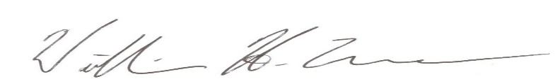

Printed Name: William Hunter Frame
Title: Field Crop Agronomist/Associate Professor

References:

Colaḉo, A., M. Schaefer, and R. Bramley. 2021. Broadacre Mapping of Wheat Biomass Using
Ground-Based LiDAR Technology. Remote Sensing. 13:3218. https://doi.org/10.3390/rs13163218

Franzen, D., J. Camberato, E. Nafiziger, D. Kaiser, K. Nelson, G. Singh, D. Ruiz-Diaz, E. Lentz,
K. Steinke, J. Grove, E. Ritchey, L. Bortoion, C. Rosen, B. Maharjan, and L. Thompson. 2023. Performance of Selected Commercially Available Asymbiotic N-fixing Products in the North Central Region. NDSU Extension: SF2080.

Futerman, S., Y. Laor, G. Eshel, and Y. Cohen. 2023. The potential of remote sensing of cover
crops to benefit sustainable and precision fertilization. Science of the Total Environment. 891:164630. http://dx.doi.org/10.1016/j.scitotenv.2023.164630

Geissinger, M. D. Marzu, and M. Broeske. 2024. A review of common nitrogen biological
products for corn. University of Wisconsin Extension. www.ipcm.wisc.edu

Hütt, C., A. Bolten, H. Hüging, and G. Bareth. 2023. UAV LiDAR Metrics for Monitoring Crop
Height, Biomass and Nitrogen Uptake: A Case Study on a Winter Wheat Field Trial. 2023. PFG. 91:64-76. https://doi.org/10.1007/s41064-022-00228-6

Miller, J., A. Shober, and J. Taraila. 2024. Assessing relationships of cover crop biomass and
nitrogen content to multispectral imagery. Agronomy Journal. DOI: 10.1002/agj2.21554

Prabhakara, K., W.D. Hively, G. McCarty. 2015. Evaluating the relationship between biomass,
percent groundcover and remote sensing indices across six winter cover crop fields in Maryland, United States. International Journal of Applied Earth Observation and Geoinformation. 39:88-102. http://dx.doi.org/10.1016/j.jag.2015.03.002

Swoish, M., J. Da Cunha Leme Filho, M. Reiter, J. Campbell, and W. Thomason. 2022.
Comparing satelittes and vegetation indices for cover crop biomass estimation. Computers and Electronics in Agriculture. 196: 106900. https://doi.org/10.1016/j.compag.2022.106900

