SUMMARY OF THE 2025 FINAL REPORT TO THE VIRGINIA CORN BOARD

Name and Address of Principal Investigators: Tim Bryant, Virginia Tech Tidewater AREC, Suffolk, VA (Co-PI’s: Kemper Sutton and Tom Kuhar)

Project Title: Comparing group 30 insecticide seed treatments and in-furrow applications to existing seed treatment products

Objective of Research: To determine insect injury, plant stands, and yields of corn planted with different seed- and soil-applied insecticides

Summary of Results:
In 2025, we conducted replicated small-plot experiments in Suffolk, Whitethorn, and the Eastern Shore of Virginia to determine the efficacy of seed and soil-applied insecticides against early-season pests of corn (e.g., wireworms, white grubs, slugs). Each of the three sites represented different potential pest pressures, but ultimately, the density of early-season pests was low at all sites (<1 wireworm trap in pre-plant counts). As expected based on the pest pressure, we identified no significant differences between insecticide treatments in stand establishment, plant height, or vigor ratings. While we did have slug pressure in the trial in Suffolk, VA, the peak density did not overlap with the early stages of corn growth, which are susceptible to injury. Additionally, there was no significant difference between insecticide treatments on slug injury. We did not expect the treatments to affect slugs, but there is potential for insecticides to affect the beneficial insects that feed on slugs. The results of these three studies demonstrate the limited value that high rates of seed treatment or in-furrow insecticides have for many corn producers. More data is needed to confirm results under a wide range of environmental and planting conditions.

We thank the Virginia Corn Board for their support.
Virginia Corn Board

2025 FINAL REPORT

Name and Address of Leaders:
Principal Investigators Tim Bryant (Co-PI’s: Kemper Sutton, Tom Kuhar)
Department Tidewater Agricultural Research & Extension Center
Virginia Tech
Mailing Address 6321 Holland Road
Suffolk, VA 23437
Telephone (757) 807-6567
Fax (757) 657-9333
Email btim2@vt.edu

Project Title: Comparing group 30 insecticide seed treatments and in-furrow applications to existing seed treatment products

Objective of Research: To determine insect injury, plant stands, and yields of corn planted with different seed- and soil-applied insecticides

Methods:
Treated ‘KSC 6114VT2P’ corn seed was provided by BASF. Treatments consisted of:
1) Fungicide only
2) Clothianidin @ 0.25 mg a.i./seed (Poncho 250)
3) Clothianidin @ 1.25 mg a.i./seed (Poncho 1250)
4) Thiamethoxam @ 1.25 mg a.i./seed (Cruiser)
5) Chlorantraniliprole @ 0.25 mg ai/seed (Lumivia)
6) Broflanilide @ 1 oz/A (liquid in-furrow) (Nurizma)
7) Isocycloseram @ 2.5 oz/A (liquid in-furrow) (Plinazolin)

Treatments 6 and 7 used seed treated with fungicide only. At the eastern shore location, only treatments 1-5 were included.

At all sites, a randomized complete block experimental design was utilized, with 4 replicates. Plot size varied by location due to availability of space and equipment. In Suffolk and the eastern shore plots were four rows wide (36-inch centers) by 30 or 35-ft long. In Whitethorne, plots were 2 rows wide by 20-ft long with 0.8 seed/ft hand-planted. Plots were planted on April 21, May 8, and May 28 in Suffolk, Eastern Shore, and Whitethorne, respectively. Four wireworm traps (baited with germinating barley and corn seed) were placed in the field for 7-9 days just prior to planting at each location. This allowed an assessment of wireworm pressure prior to planting. Wireworm densities were low at all locations (< 1 per trap). Whitethorn had manure applied and cultivated into the land two weeks prior to planting to encourage seedorn maggot infestation.

Early season data on plant growth and insect injury were collected three times; at V2, V4, and V6 (or roughly weekly). Data collected included plant height, stand, plant vigor, insect injury (holes, tillers, etc.), slug counts, and slug injury. Plots were hand or machine-harvested at physiological maturity for yield.
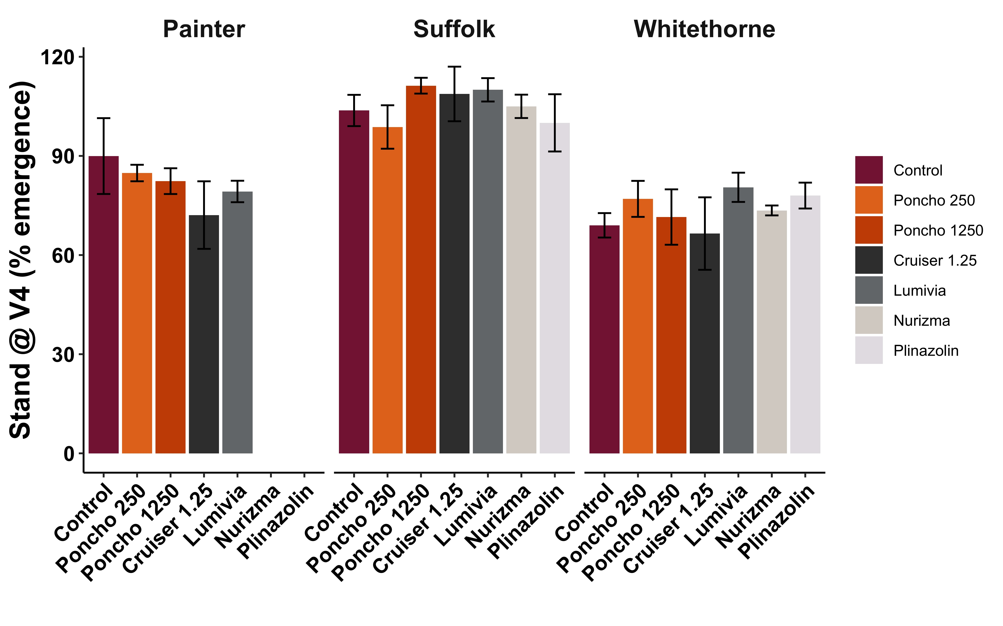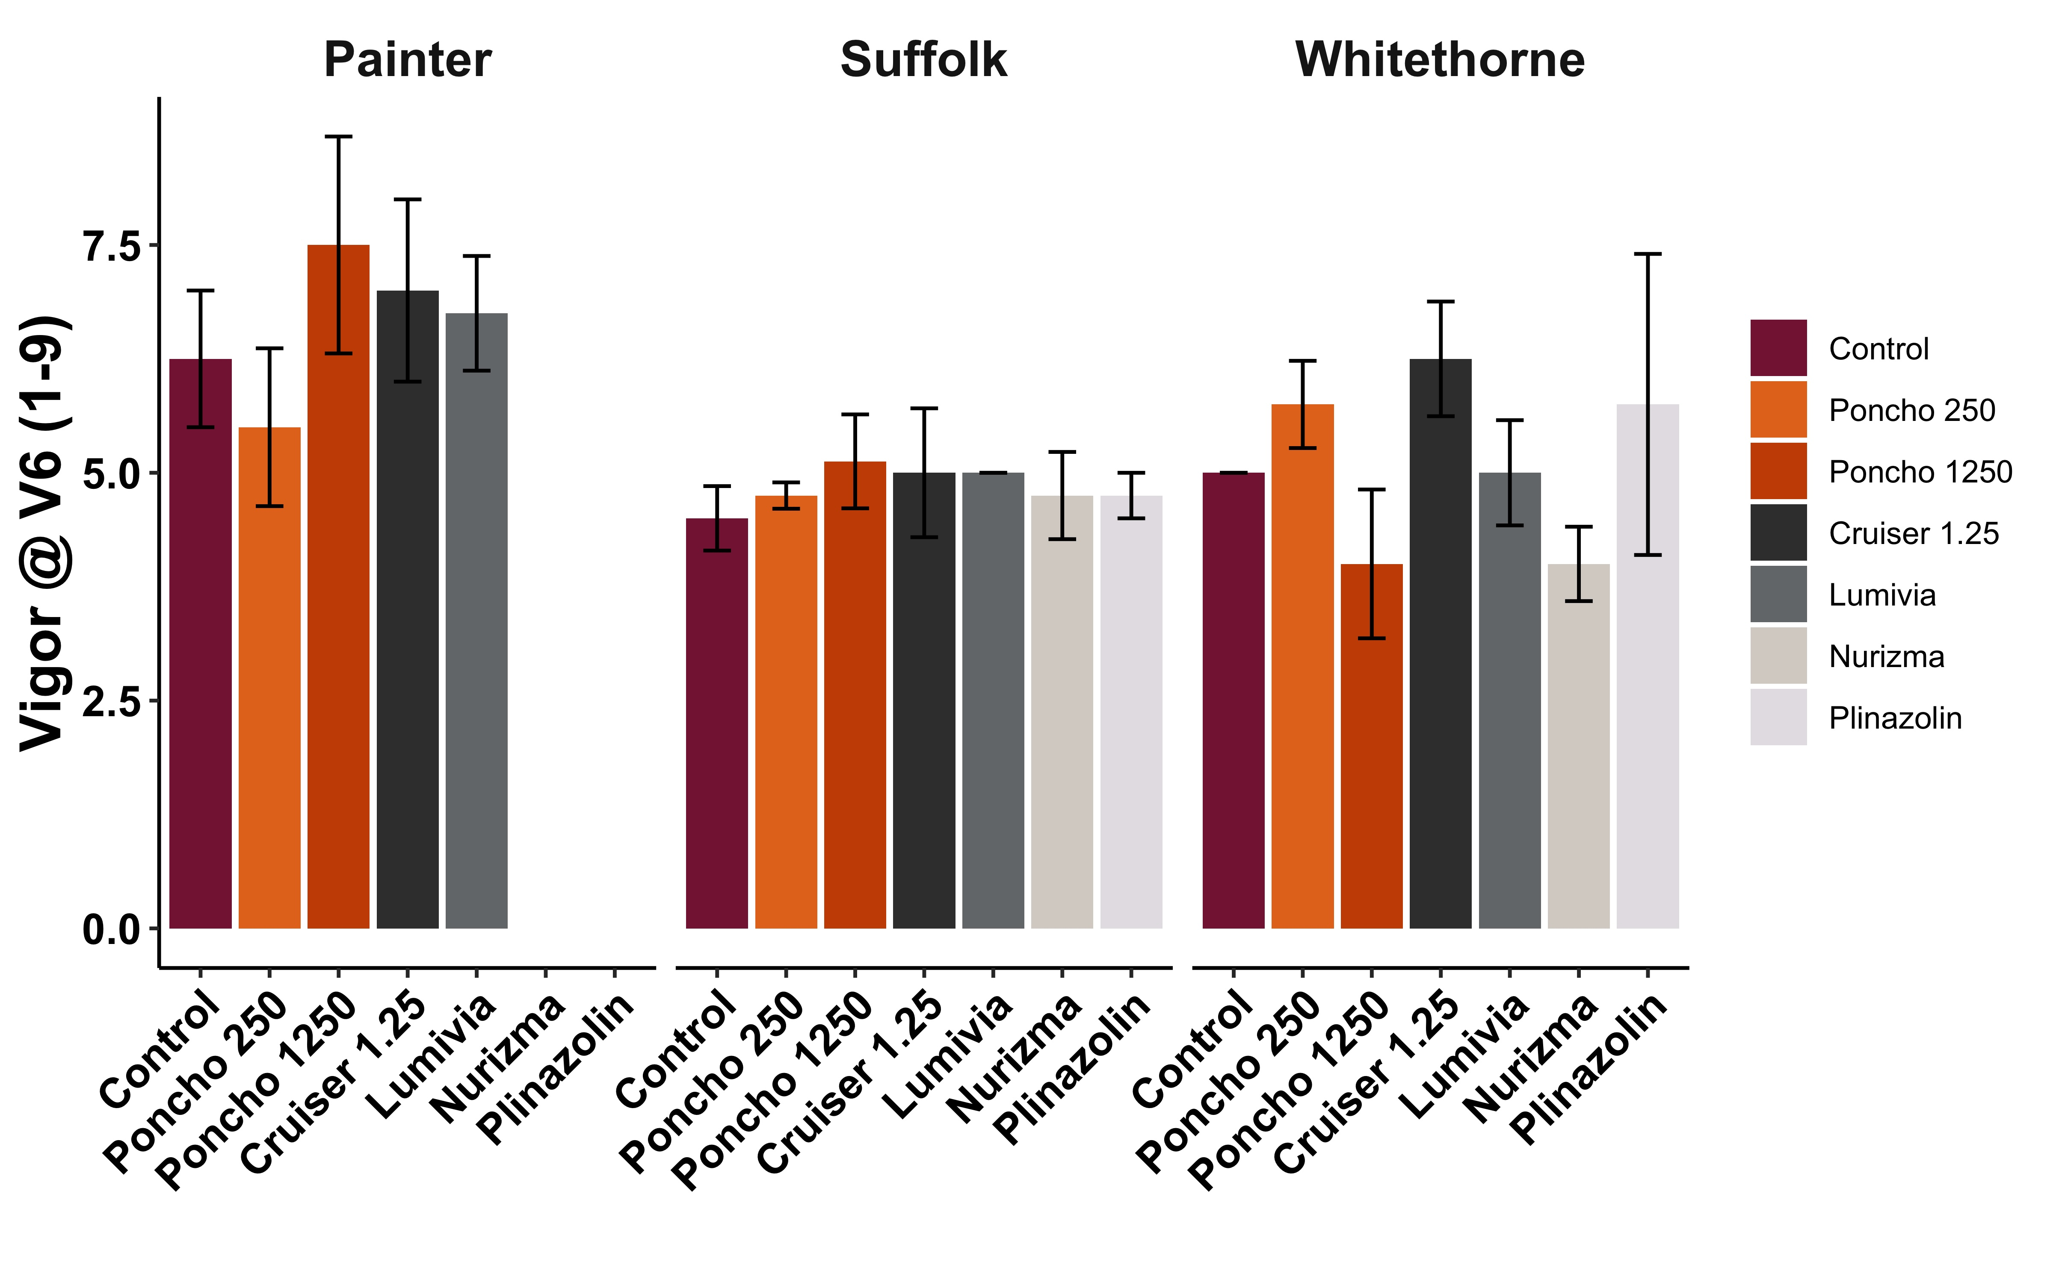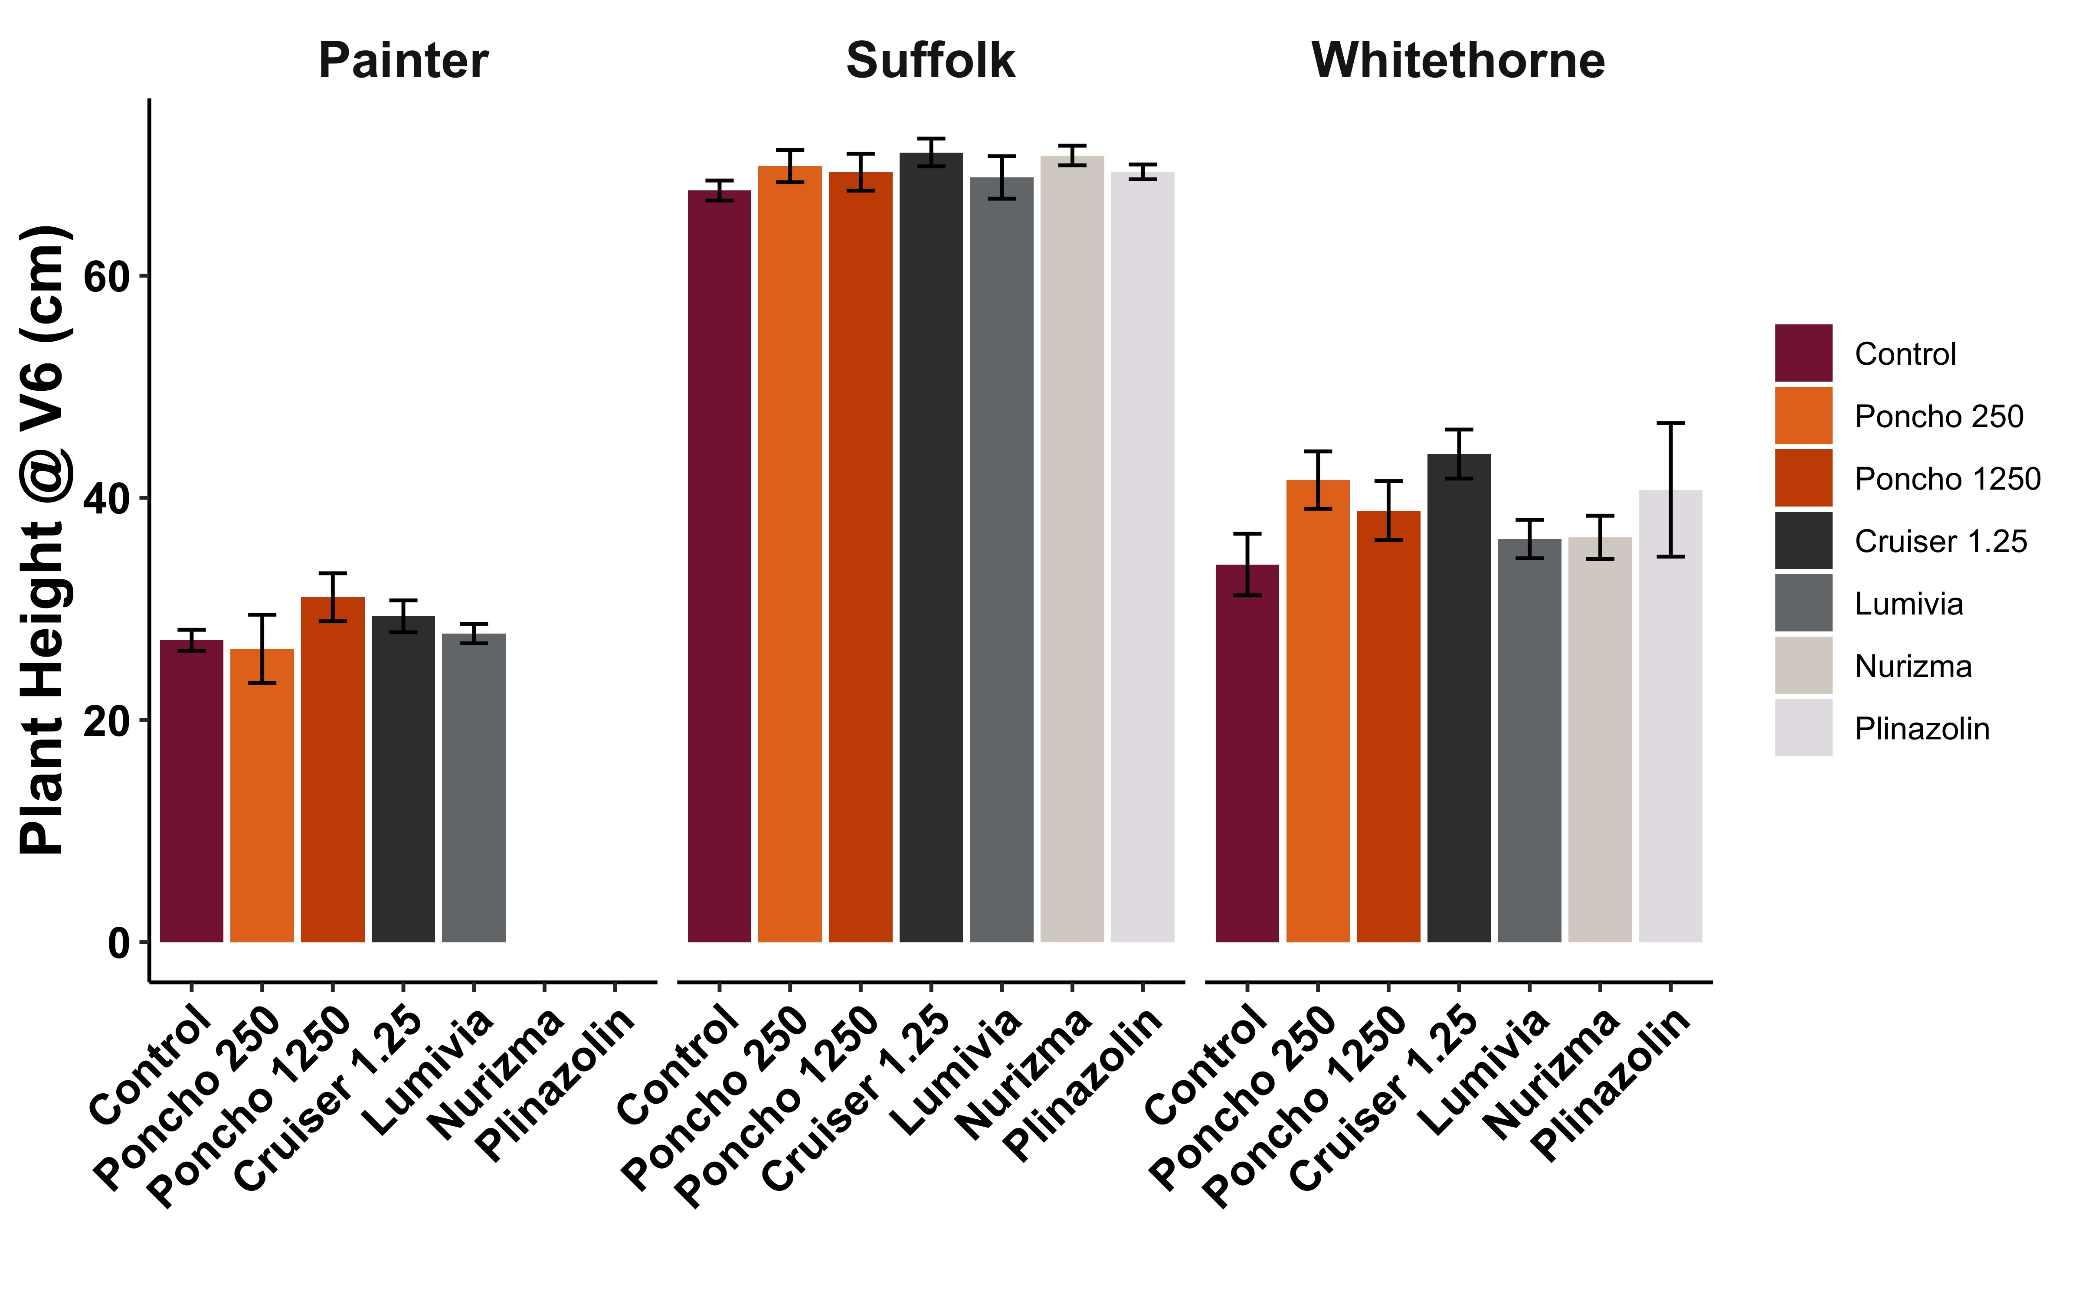
Figure 1. Stand (% emergence), plant vigor (1-9), and plant height (cm) at growth stage V4 or V6 at three study sites. No significant differences were identified between insecticide treatments.

Results and Discussion:
One Conoderus vespertinus (tobacco wireworm) larva was recovered in the baited wireworm traps at the Suffolk location. No wireworms were found in traps at the Eastern Shore and Whitethorne locations. Manure was applied two weeks prior to planting to encourage infestation Manure was applied two weeks prior to planting to encourage infestation. Seed corn maggot cannot be monitored using the same type of trap. Early season plant measurements like stand serve as a proxy for determining if any injury occurred.

No significant differences were identified in plant stand, plant vigor, or plant height between insecticide treatments (Fig. 1). It has sometimes been reported that high rates of neonicotinoid seed treatments can boost plant vigor early in the season even in the absence of insect pest pressure, but that was not observed in this study. Plant growth was overall more advanced at the Suffolk location at the V6 growth stage relative to the other two locations.

There was slug pressure present at the Suffolk location. Slugs peaked at just under 14 per shingle trap on May 14 (Fig. 2). Slug injury increased across all treatments from V4 to V6, corresponding with this peak, but injury was very minor across all treatments (Fig. 2). By the V6 stage, most slug injury is cosmetic, and the plants can quickly recover. While not statistically significant, there was, on average, less slug injury observed in the untreated control relative to the insecticide-treated plots (Fig 2). This finding potentially supports the idea that insecticides at planting may negatively impact beneficial insects that feed on slugs, making slug injury worse.
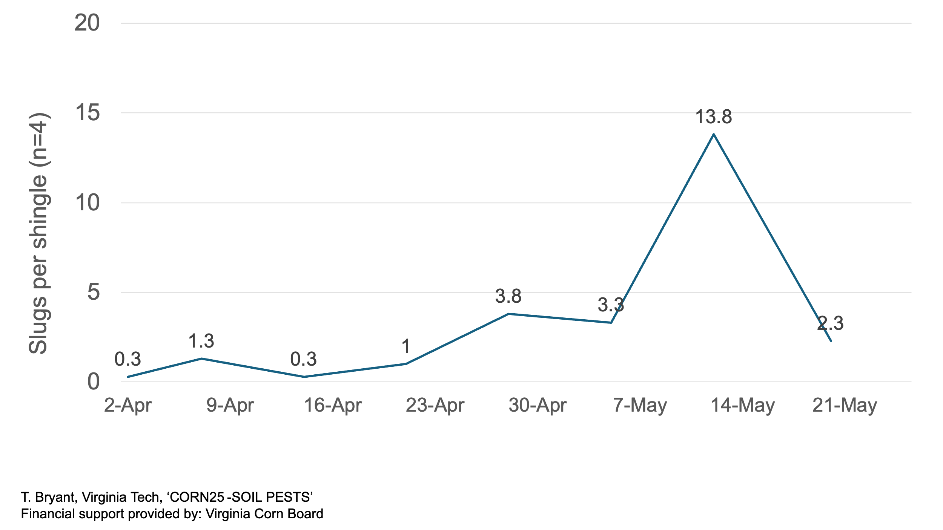
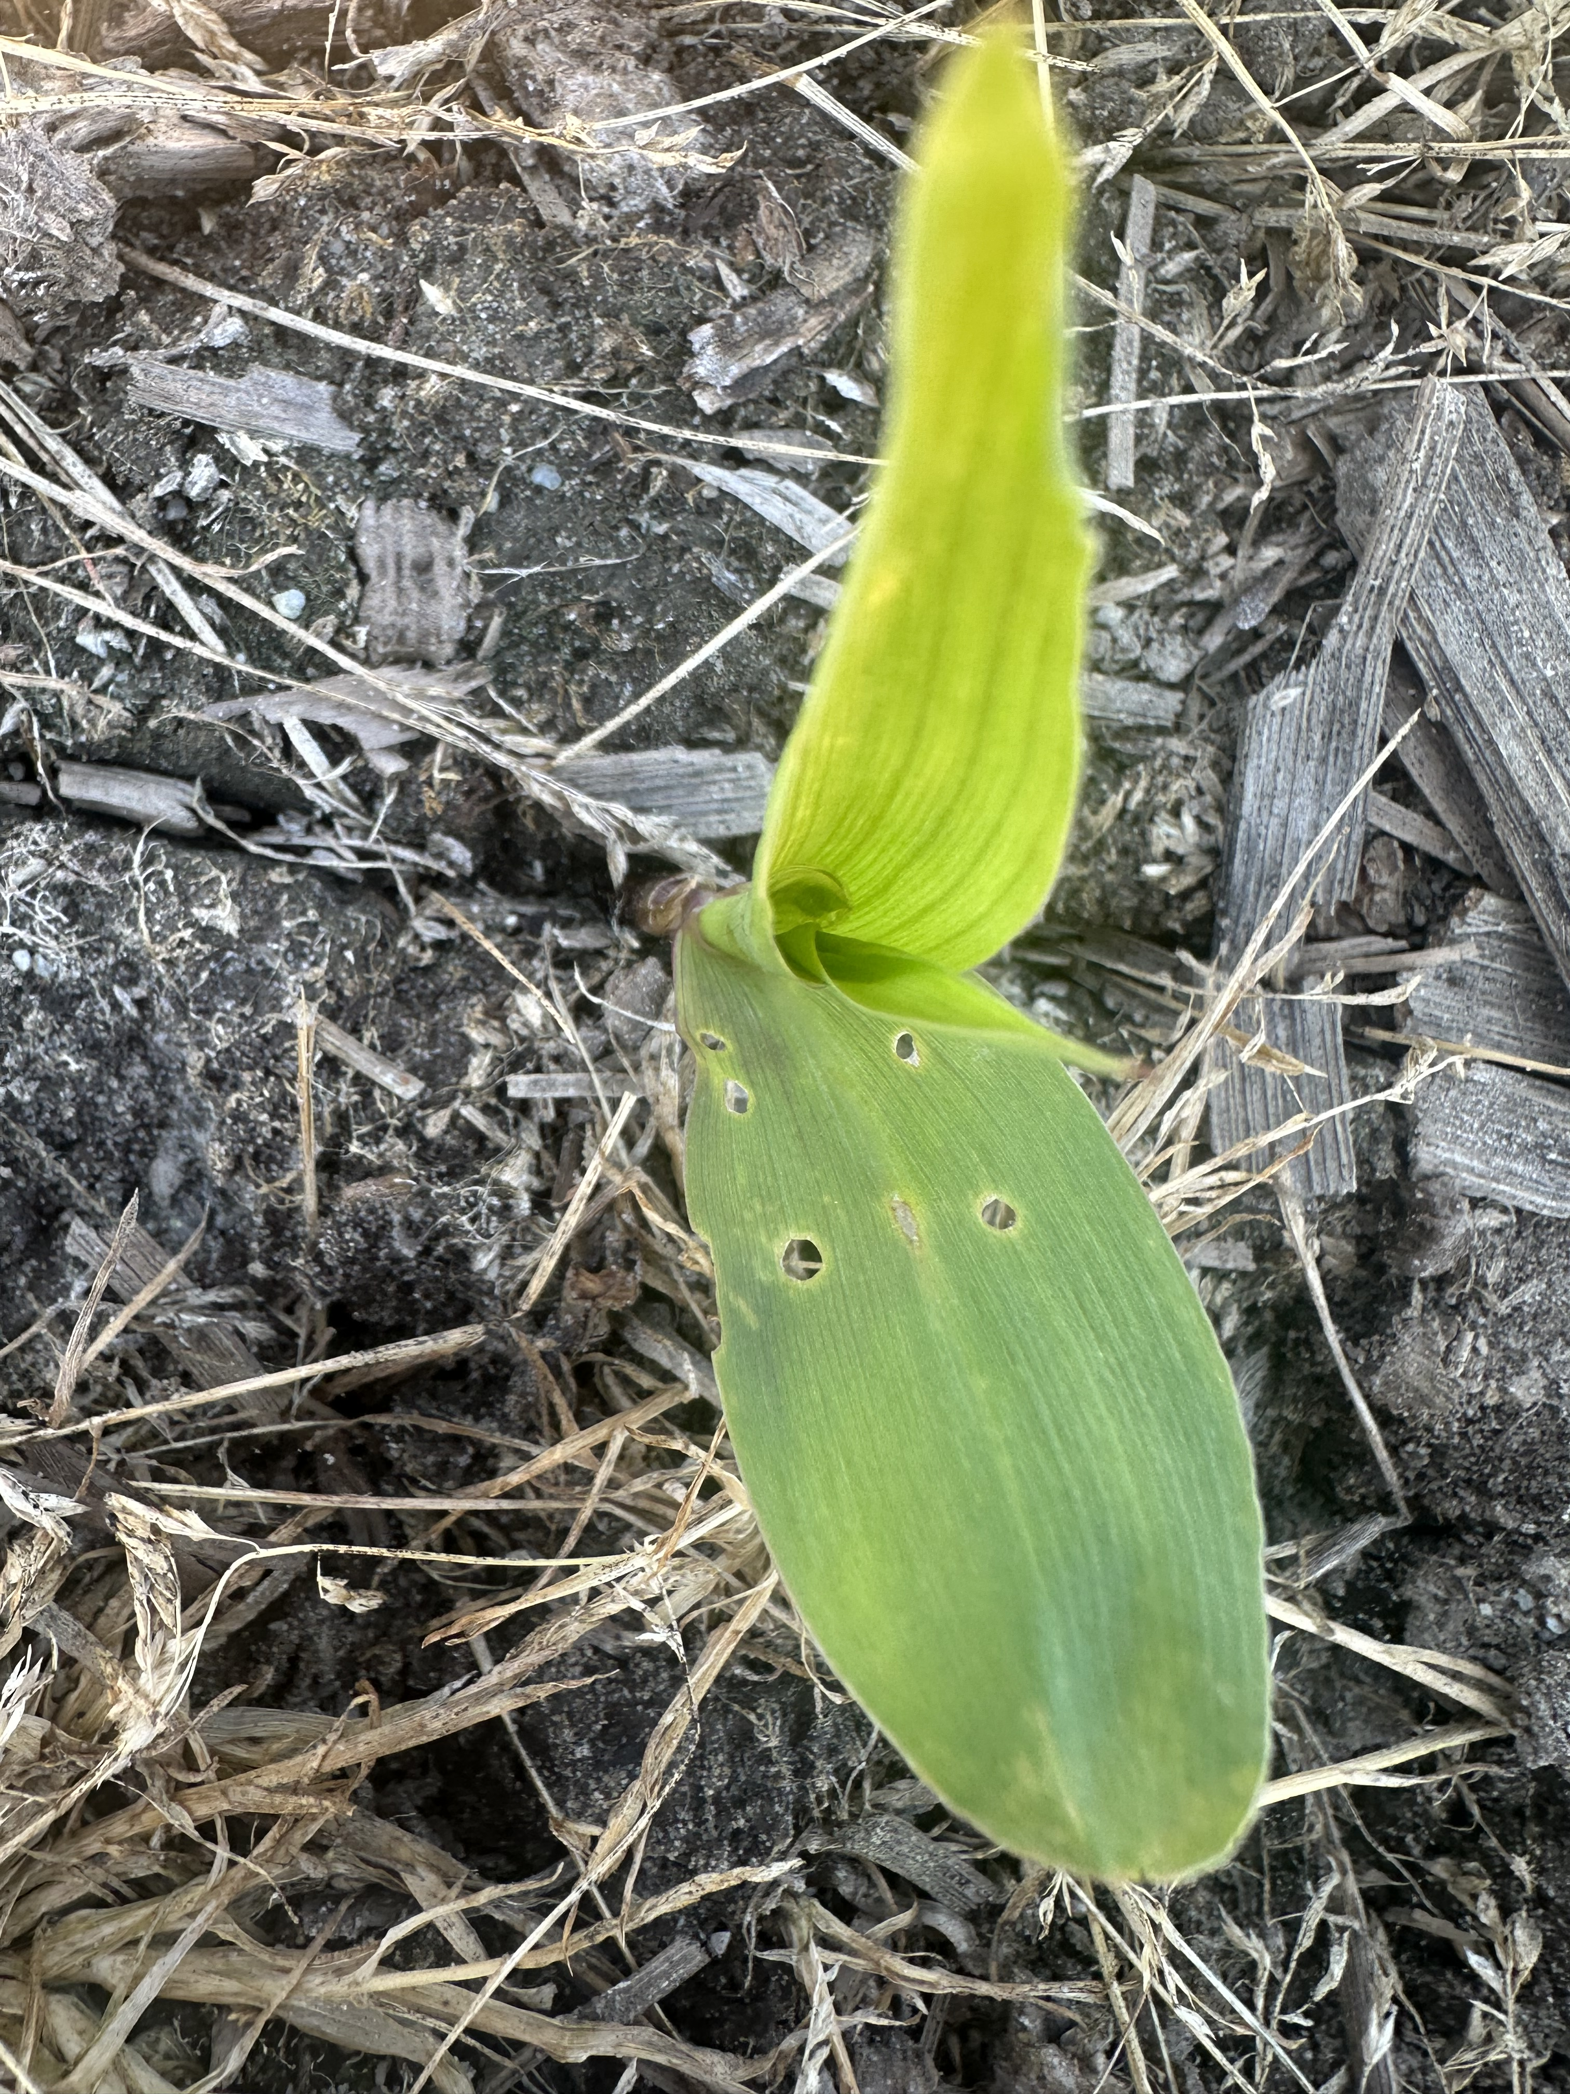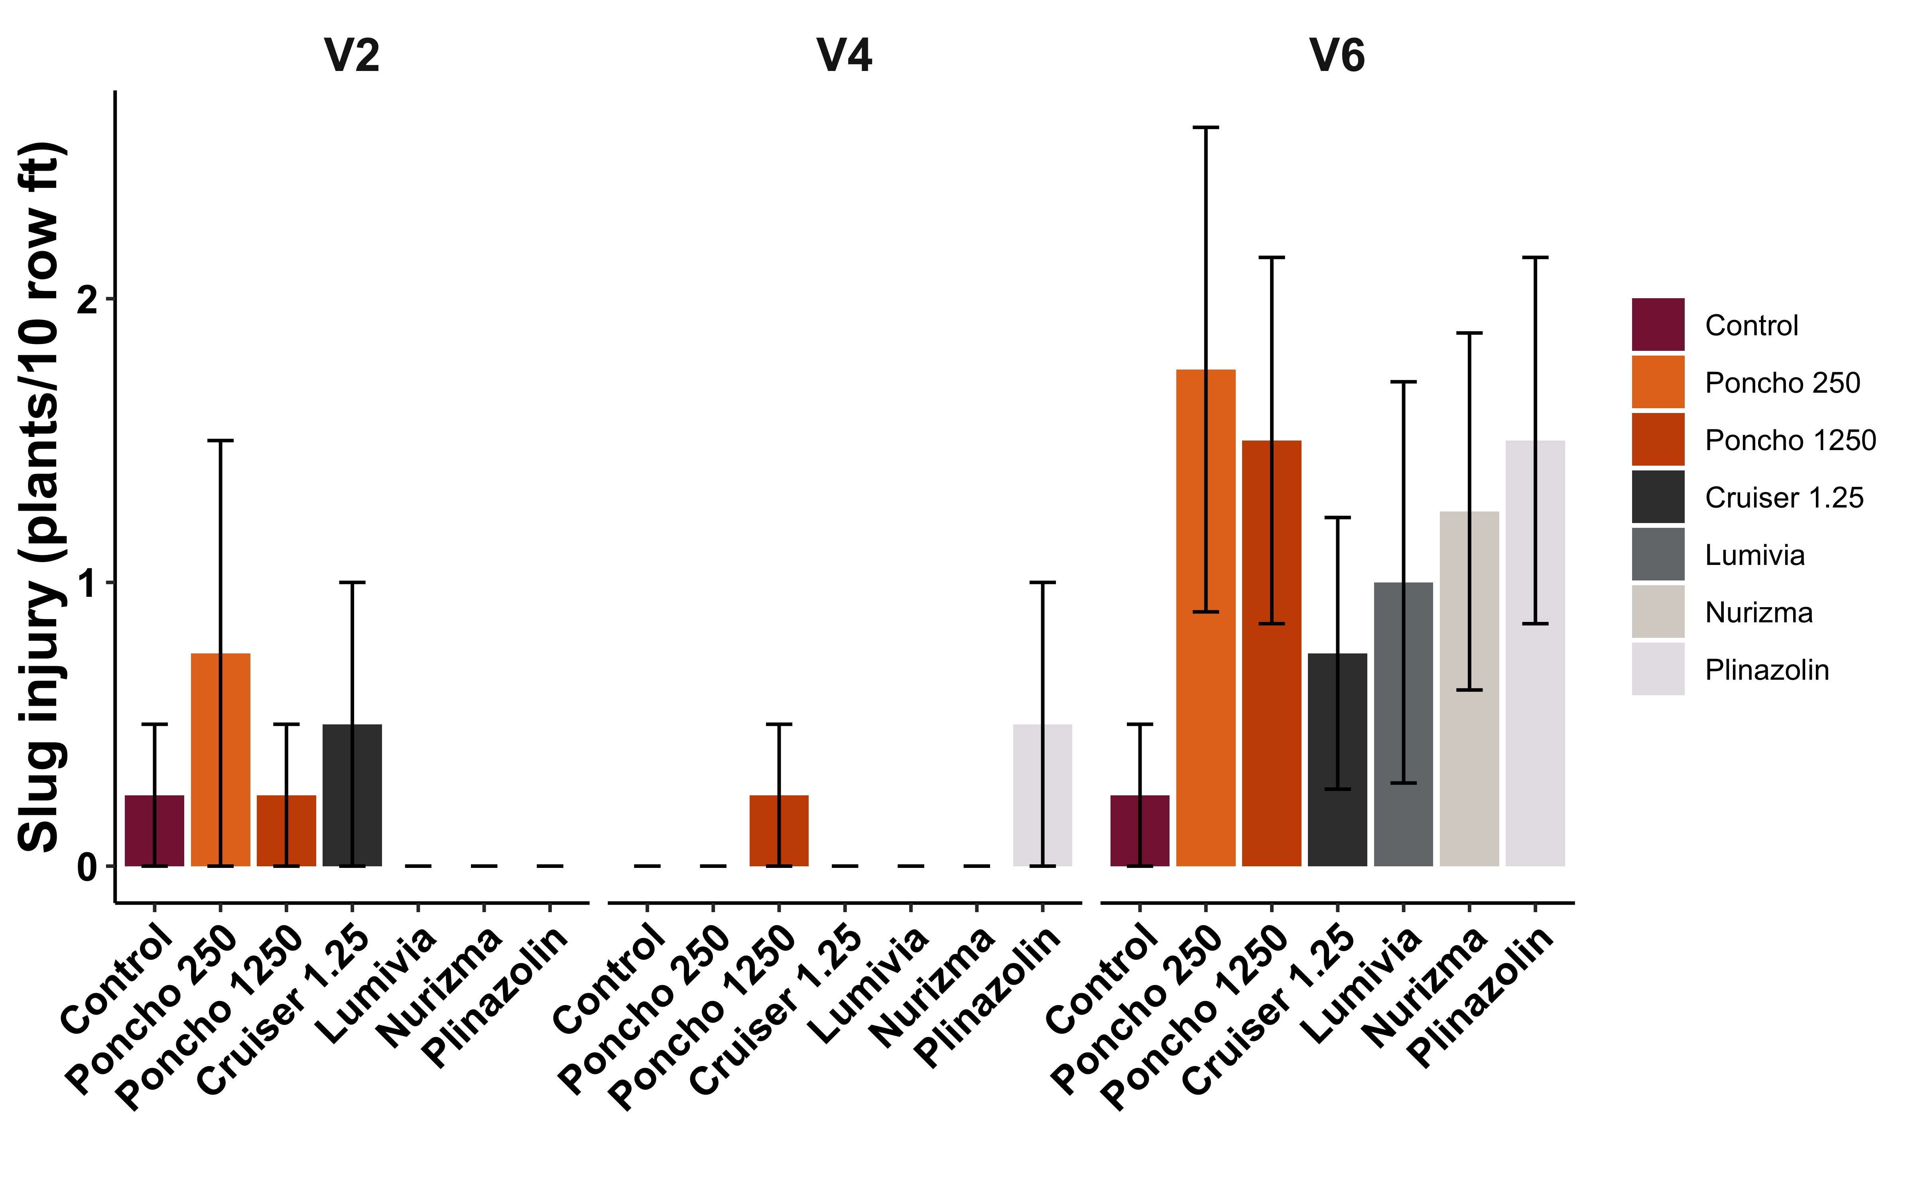

Figure 2. Weekly slug counts per 1 x 1 foot shingle trap and slug injury (number of plants injured per 10 row feet) at V2, V4, and V6 in the Suffolk, VA location. The photo illustrates the severity of slug injury observed. It was very minor, but occurred more commonly on average in treated plots.

As expected, yield did not vary between treatments at any location (Table 1). Average yield varied at the Eastern Shore location, but there was a large degree of variability due to deer and hail damage.

Table 4. Yield data at all three locations.
# | Treatment | Rate | Eastern Shore (bu/ac) | Suffolk (bu/ac) | Whitethorne (20 ear weight (kg))
1 | Fungicide-only |  | 149.6 | 133.5 | 13.4
2 | Poncho 250 | 0.25 | 120.1 | 135.0 | 17.1
3 | Poncho 1250 | 1.25 | 174.1 | 149.0 | 15.3
4 | Cruiser 1.25 | 1.25 | 181.7 | 130.8 | 15.3
5 | Lumivia | 0.25 | 163.9 | 128.0 | 15.8
6 | Nurizma | 1 | - | 122.1 | 16.6
7 | Plinazolin | 2.5 | - | 142.0 | 16.8
 | P(F) |  | 0.52 | 0.52 | 0.55
Means within a column followed by the same letter(s) are not significantly different (Tukey’s HSD, P=0.05).

Conclusions
This study illustrated the limited value that seed treatments or in-furrow applications may have for corn production across Virginia. While there are specific scenarios where these treatments are valuable tools, across the vast majority of our production area, soil pest pressure is sporadic and limited. We measured plant height, vigor, stand, insect injury, and slug injury and identified no significant differences between any of the tested treatments. While more data is needed to confirm these results under as many sets of environmental and planting conditions as possible, preliminary results indicate that seed treatments may be a good place to save on seed costs. Growers are likely not able to purchase totally untreated seed, but being informed on various rates and formulations allows them to make informed purchases and avoid spending more on a higher rate that doesn’t provide a return on that investment.

Acknowledgements:
We thank the Virginia Corn Board for financially supporting this project.

