VIRGINIA CORN BOARD

PROJECT PROPOSAL – 2026/2027

Title: Utilizing Cover Crops to Offset Fertilizer Inputs for Corn in Virginia – TAREC
Principal Investigator: Dr. William Hunter Frame
Field Crop Agronomist/Associate Professor
6321 Holland Rd, Suffolk, VA 23437
757-653-8292 (cell)
whframe@vt.edu

Collaborators: Dr. Mark Reiter, Director and Extension Specialist of Soils and Nutrient Management
757-807-6576
mreiter@vt.edu

Project Initiation: April 2025

Project Duration: April 2024 – March 2030 (1-year for the current proposal)

Objective: The overall objective of this project is to research the impact of various cover crop species and crop rotations on corn yield, and cover crops’ ability to offset nitrogen and other macro nutrient fertilizer inputs.

Location: Tidewater Agricultural Research and Extension Center

Summary of 2nd year results (2025 Proposal Report)
The growing season of 2025 was good for corn in general in the Tidewater Region, however the soil type in the field where the cover crop study is located is very compacted resulting in corn yields that were below other studies implemented with strip-tillage. The cover crop biomass and nutrient uptakes are found in Table 1 for the spring of 2025, which was the first year of cover crops in this study. Of the nine different mixes and systems with cover crops dry biomass was significant with hairy vetch having the highest total biomass followed by the
Table 1: Cover crop system dry biomass and nutrient accumulation prior to Summer 2
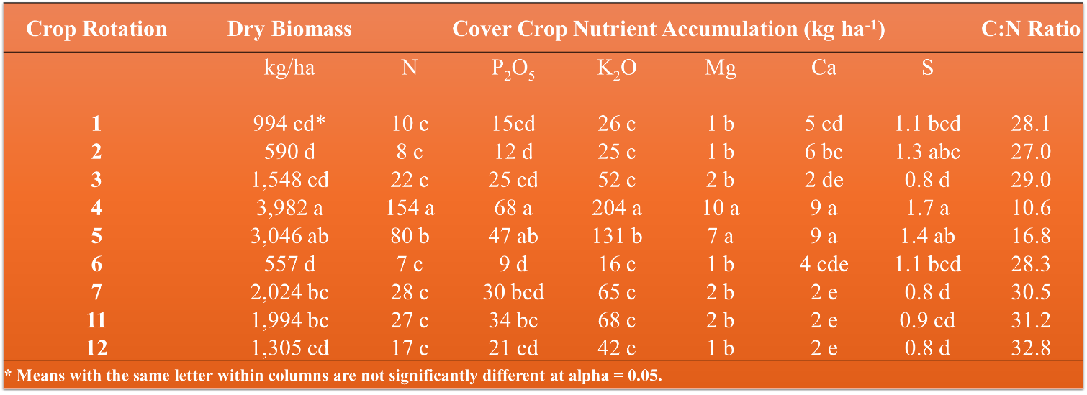

kitchen sink (multi-specie mix) mix. The lowest biomass accumulation was the no-till + fallow (Rotation 2) (Table 2). Only the hairy vetch cover was the only cover crop mixture to accumulate over 100 lb N per acre (145 lb N per acre) and over 200 lb K₂O per acre in the above ground biomass (Table 2).
There were also winter wheat and soybean systems in the study where there were no treatment differences. The soybean (both full-season and double crop) averaged 55 bushels per acre, while the winter wheat averaged 60 bushels per acre. For the full-season soybeans, deer feeding pressure resulted in replanting thus the similar yields to double crop soybeans during the 2025 growing season.
There were large differences to N application rates across the crop rotations/cover crop treatments during the 2025 growing season. Figure 1 has the base line corn grain yield response to N application rates at the trial initiation in 2024. In 2025, hairy vetch had the highest grain yields at the 0 lb N per acre rate and was twice as high as the nearest other system which was the “Kitchen Sink” mix (Figure 3). Only the conventional tillage with 200 lb N per acre approached yield levels to the hairy vetch cover crop in 2025. No other cover crop/cropping rotation reached
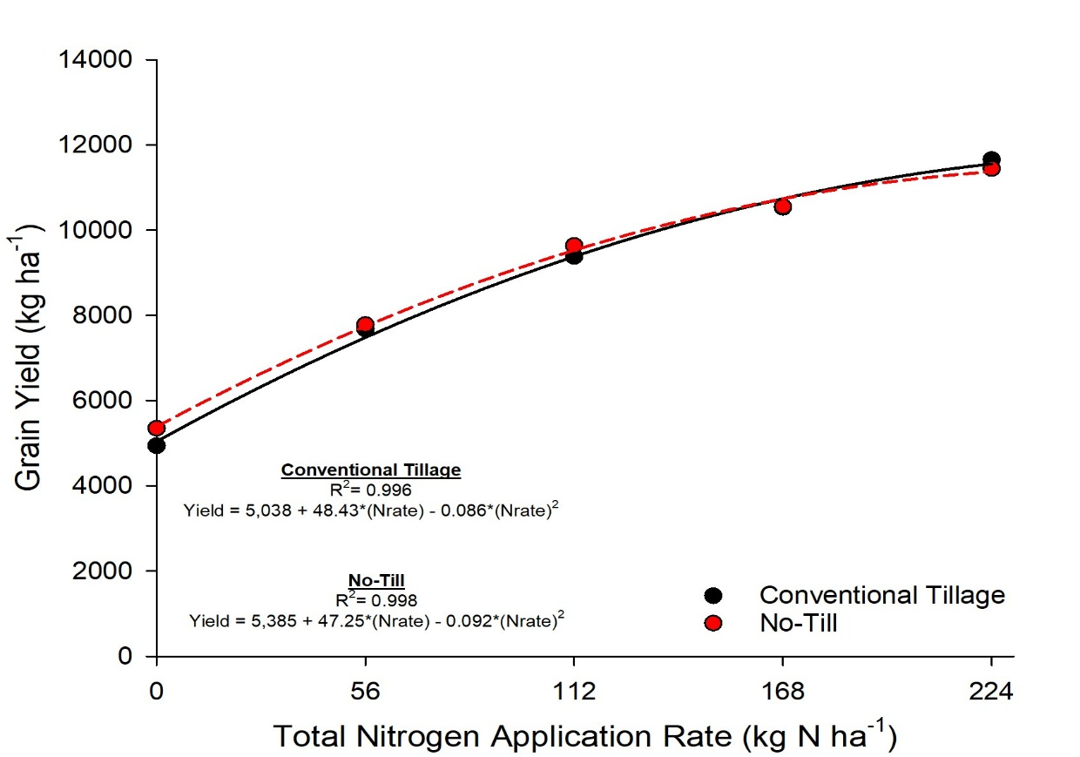
Figure 1: Initial corn grain of site in response to N application rates in 2024.

even the grain yield of hairy vetch at 0 lb N per acre (Figure 3). Cereal rye cover was the only cover crop that had a linear response to N application rate during 2025, which is indicative to N being immobilized by the high CN ratio of cereal rye at termination (Figure 3). All fallow and cereal rye 0 lb N per acre grain yields were 25% of hairy vetch during for the 2025 growing season.
The response to various cover crops in 2025 is indicative to the response observed in similar cotton studies. The 2025 study is a textbook case to demonstrate the potential for leguminous cover crops to supply N, even in environments where high yield potential is not achievable. This is just the beginning of this research trial and it will be interesting to see how this response changes in the years to come.
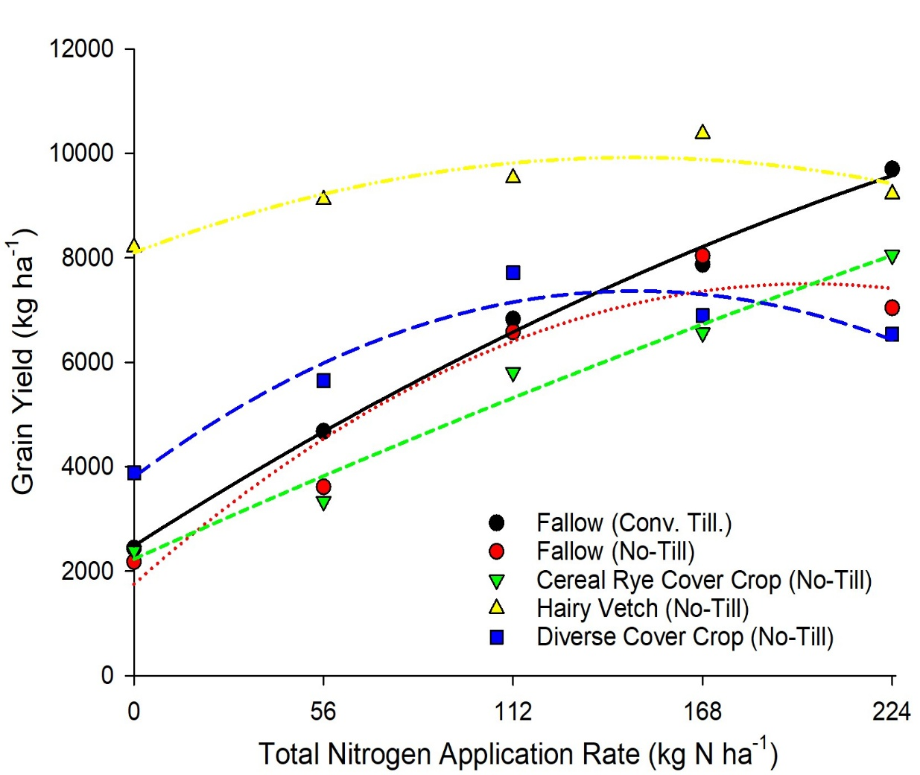
Figure 2: Corn grain yield for various N application rates following single species and cover crop mixes in 2025. (8,000 kg/ha = 128 bu/ac).

2026 Research Proposal
Justification
Drastic increases in fertilizer costs have greatly impacted the profitability of corn production in Virginia. In 2022, we saw an average of $1.11/lb. of nitrogen and K₂O; which were an 80% and 56% increase in the average price of bulk urea and potash, respectively, when compared to 2021 averages (USDA-AMS, 2023). While fertilizer prices have come down in 2023, they are still above pre-Ukraine war averages in 2021. In 2023, we saw an average of $0.76/lb. of nitrogen and $0.80/lb. of K₂O, which were still a 24% and 12% increase in the average price of bulk urea and potash, respectively when compared to 2021 averages. The on-going volatility in the global market has future projections of fertilizer prices remaining at historically high prices (The Fertilizer Institute, 2022).
Cover crops were shown to reduce required fertilizer inputs, especially in regards to nitrogen, when utilizing legume cover crop species like hairy vetch (Finney et al., 2016; Norris et al., 2020). Employing cover crop mixtures of both legume and non-legume species can minimize the inherent tradeoffs between N supply and N retention services these cover crops provide when planted in monocultures (Finney et al., 2016, 2017; White et al., 2017). Furthermore, highly leachable nutrients like potassium [on low cation exchange soils (CEC); i.e. sandy loam and loamy sands of the Coastal Plain] can be mined from deep within the soil profile by cover crops and released from cover crop biomass to the concurrent corn crop that growing season (Sharma et al., 2018). Previous results suggested that utilizing cover crops can greatly reduce or even eliminate the need for additional nitrogen fertilizer (Wolters, 2019), but further research is still needed before making recommendations to Virginia corn producers and to further investigate the cycling of potassium and other macronutrients in the corn rotation.
Background
China recognized the benefits of cover crops as far back as 1134 B.C. (Joffe, 1955) and farmers since have incorporated these soil saving rotational plants into their production systems. Even George Washington implemented cover crops into his crop rotation at Mount Vernon, referring to them as “crops grown to replenish the soil” and was one of our nation’s earliest cover crop promoters (Groff, 2015). According to a summary by Reeves (1994), cover crops must meet the following factors in order to earn merit: 1) be easy to establish, 2) have a rapid growth rate to provide ground cover quickly, 3) produce a sufficient quantity of dry matter for maintenance of residues, 4) be disease resistant and not act as a host for disease-causing organisms, 5) be easy to kill, and 6) be economically feasible.
In the Mid-Atlantic, many types of cover crops are valued and can be used readily in production systems (Schonbeck and Morse, 2006). Generally, two main “types” of winter cover crops are used that include grasses and legumes, although brassicas can be used if hard pans are present or pest management characteristics resulting from isothiocyanate production during desiccation are desired (Reeves, 1994; Treadwell et. al., 2010). Legumes are “lower residue” cover crops, that through symbiotic relationships with bacteria fix valuable N from the atmosphere and can aid in nutrient management programs by acting as an organic nutrient source. However, grasses tend to have root systems that recover nutrients from deep in the soil profile and provide more biomass than legumes. Combining both legumes and high C:N ratio grasses will produce high biomass while maintaining C:N ratios favoring mineralization of N in biomass. This will aid in biomass decomposition and nutrient cycling in crop rotations. Other cover crops, such as rapeseed, introduce species which can penetrate deep into the soil profile with its root system.
Procedure
To meet the objectives of this project, we will evaluate impacts of various cover crops and crop rotations on corn yield in our long-term cover cropping systems research plots at the Tidewater Agricultural Research and Extension Center (TAREC). This research site was established in the spring 2024 to observe the effects of 12 different crop rotations on soil health and cash crop yields. The study has a 2-year repeating crop rotation, as seen in Table 1. Each crop rotation is replicated 4 times. Following 2024 corn harvest, cover crops were planted on September 2024. In 2025, five treatments will be planted in corn with these being our continuous corn treatments. Within the corn management systems, five N application rates will be applied and will be 0, 50, 100, 150, and 200 lb N per acre. On the remaining seven cover crop systems either will be full-season or double crop soybeans. Other than summer crops all other management strategies will follow Virginia Cooperative Extension recommendations.
Aboveground cover crop and weed biomass samples will be collected at termination, 1-3 days prior to corn planting, four 0.125 m² samples per plot. Dry biomass weights will be recorded, and these samples will be analyzed for both macro- (%N, P, K, Ca, Mg, S) and micronutrients (ppm-B, Zn, Mn, Fe, Cu), as well as total carbon. Additionally, at corn planting, soil samples will be taken in each main plot at 0-6 and 6-12 inches; and analyzed for soil pH, as well as other general crop macro and micronutrients. Soil moisture samples will be collected with a handheld soil moisture probe to evaluate the impact of cover crops, crop rotation, and tillage method on soil moisture throughout the corn growing season.
Corn growth and development will be visually monitored, and notes taken on any abnormalities, diseases, etc. Normalized Difference Vegetation Index (NDVI) measurements will be taken multiple times throughout the growing season with a multispectral camera on an unmanned aerial vehicle (UAV) to evaluate corn greenness and health. Plant tissue samples will be taken (corn ear leaf at R1) and analyzed for the following macro- (%N, P, K, Ca, Mg, S) and micronutrients (ppm-B, Zn, Mn, Fe, Cu). At maturity, corn will be harvested, yield calculated at 15.5% moisture, and the grain analyzed for macro- and micronutrients. Additionally, similar measurements and samples will be collected from the wheat and soybeans grown in treatments 6-12, in 2025, to evaluate nutrient cycling for the following corn crop. Results will be compiled into extension publications and presented to growers during winter meetings in 2025/2026.
Personnel and Facilities
This project will be based at the Tidewater AREC in Suffolk Virginia. This project will require the labor of post (Ms. Chessie Beery, MS student and Extension faculty/staff (Dr. Hunter Frame and Mr. Billy Taylor), various farm workers, and summer technicians to establish plots, collect and analyze soil and tissue samples, harvest, data analysis, and reporting. The Tidewater AREC has laboratory facilities for nutrient sample preparation, sample analysis for carbon, nitrogen, potassium, and sulfur, and necessary tractors, combines, spraying equipment, and other necessary resources to complete this project.
Other Entities
We will contract with private laboratories to analyze cover crop, corn, and corn grain biomass for macro- and microelements as private laboratories can conduct the work cheaper than Virginia Tech labs.

Source of Other Funds
Private industry sponsored research funds will be used to pay tuition for the graduate student working on this project along with other non-allowable indirect charges (electricity, equipment, vehicle expenses, etc.).

Budget: Graduate Student Stipend $18,098
Graduate Fringe $ 1,683

Materials and Supplies $ 2,000
Contractual Services $ 3,750

Total $25,531

Submitted by:
Signature:

Printed Name: William Hunter Frame
Title: Field Crop Agronomist/Associate Professor

References:

Finney, D. M., Murrell, E. G., White, C. M., Baraibar, B., Barbercheck, M. E., et al. 2017. Ecosystem Services and Disservices Are Bundled in Simple and Diverse Cover Cropping Systems. Agricultural & Environmental Letters, 2(1), 170033. https://doi.org/10.2134/AEL2017.09.0033
Finney, D. M., White, C. M., & Kaye, J. P. 2016. Biomass production and carbon/nitrogen ratio influence ecosystem services from cover crop mixtures. Agronomy Journal, 108, 39–52. https://doi.org/10.2134/agronj15.0182
Groff, S. 2015. The past, present, and future of the cover crop industry. Journal of Soil and Water Conservation, 70(6), 130A-133A. https://doi.org/10.2489/jswc.70.6.130A
Joffe, J.S. 1955. Green manuring viewed by a pedologist. Adv. Agron. 7:141-187.
Norris, R., Chim, B. K., Evanylo, G., Reiter, M., & Thomason, W. 2020. Corn yield and soil nitrogen following winter annual cover crops interseeded into soybean. Crop Science, 60(5), 2667–2682. https://doi.org/https://doi.org/10.1002/csc2.20185
Reeves, D.W. 1994. Cover crops and rotations. p. 125-172. In J.L. Hatfield and B.A. Stewart (ed.) Crops residue management. Advances in Soil Science, Lewis Publishers. Boca Raton, FL.
Schonbeck, M. and R. Morse. 2006. Cover crops for all seasons [Online]. Available at: http://www.vabf.org/docs/information-sheets (verified 25 June 2011). Publ. 3-06. Virginia Assoc. Biological Farming, Richmond, VA.
Sharma, V., Irmak, S., & Padhi, J. 2018. Effects of cover crops on soil quality: Part II. Soil exchangeable bases (potassium, magnesium, sodium, and calcium), cation exchange capacity, and soil micronutrients (zinc, manganese, iron, copper, and boron). Journal of Soil and Water Conservation, 73(6), 652–668. https://doi.org/10.2489/JSWC.73.6.652
The Fertilizer Institute. 2022. Market Insights. Available at: https://www.tfi.org/ Arlington, VA.
Treadwell, D., N. Creamer, and K. Baldwin. 2010. An introduction to cover crop species for organic farming systems [Online]. Available at: http://www.extension.org/pages/18542/an-introduction-to-cover-crop-species-for-organic-farming-systems#.Uz4g-vldU-c (verified 3 Apr. 2014). eOrganics Program, eXtension Initiative, Lincoln, NE.
USDA-Agricultural Marketing Service. 2023. North Carolina Weekly Production Cost Report. Available at: https://mymarketnews.ams.usda.gov/filerepo/sites/default/files/3159/2022-12-09/658115/ams_3159_00143.pdf. Washington, D.C.
White, C. M., Dupont, S. T., Hautau, M., Hartman, D., Finney, D. M., Bradley, B., Lachance, J. C., & Kaye, J. P. 2017. Managing the tradeoff between nitrogen supply and retention with cover crop mixtures. Agriculture, Ecosystems and Environment, 237, 121–133. https://doi.org/10.1016/j.agee.2016.12.016
Wolters, B. 2019. To Mix or Not to Mix: Performance and Management of Diverse Cover Crop Mixtures. Dissertation. Virginia Tech, Blacksburg. Available at: https://vtechworks.lib.vt.edu/handle/10919/96592

Table 2. Description of the Eastern Shore AREC long-term cover cropping systems 2-year rotation. In Summer 1 (2023/2025), all treatments were/will be planted in corn and split plot design will be implemented to incorporate variable N sidedressing rates.

Treatment | 1 | 2 | 3 | 4 | 5 | 6 | 7 | 8 | 9 | 10 | 11 | 12
Description | Baseline A: All corn, tilled, no CC | Baseline A2:  All corn, no-till, no CC | All corn, grass CC, High C:N | All corn, legume CC, Low C:N | All corn, diverse CC, Mid-C:N | Baseline B: Corn/FSSB, no CC | Vetch/  Corn, Rye/FSSB | Baseline C: Corn/W/ DCSB,  no CC | Vetch/Corn/Wheat  /DCSB | Low C:N Mix/Corn/ Wheat/  DCSB | Cover Crop Mixes, Corn/FSSB | VA DCR Cost Share, Cereal Rye Rotation
Winter 1 | Fallow | Fallow | Rye | Vetch | 9sp Mix | Fallow | Vetch | Fallow | Vetch | High N Fixer 2 Mix | N Cycler 2 Mix | Rye
Summer 1  (2023/2025) | Corn (tilled) | Corn | Corn | Corn | Corn | Corn | Corn | Corn | Corn | Corn | Corn | CornSo
Winter 2 | Fallow | Fallow | Rye | Vetch | 9sp Mix | Fallow | Rye | Wheat | Wheat | Wheat | Residue Maker 2 Mix | Rye
Summer 2 (2024/2026) | Corn (tilled) | Corn | Corn | Corn | Corn | Full Season Soybean | Full Season Soybean | Double Crop Soybean | Double Crop Soybean | Double Crop Soybean | Full Season Soybean | Full Season Soybean

Table 3. Eastern Shore AREC long-term cover cropping systems, cover crop seeding rates.

Cover Crop Treatment Name | Grasses |  |  | Brassicas |  | Legumes |  |  | Forbs | Total Seeding Rate
Cover Crop Treatment Name | Black Oats | Triticale | Cereal Rye | Forage Radish | Rapeseed | Austrian Winter Pea | Crimson Clover | Hairy Vetch | Phacelia | Total Seeding Rate
 | ————————————————————— lb. acre⁻¹ —————————————————————
Rye |  |  | 112 |  |  |  |  |  |  | 112
Vetch |  |  |  |  |  |  |  | 20 |  | 20
Kitchen Sink | 10 | 10 | 10 | 1 | 1 | 10 | 3 | 4 | 1 | 50
Residue Maker 2 |  |  | 55 |  | 2 | 20 |  |  |  | 77
N Cycler 2 | 15 |  |  |  | 2 |  | 20 |  |  | 37
High N Fixer 2 |  |  | 22 |  | 2 | 30 |  | 12 |  | 66

